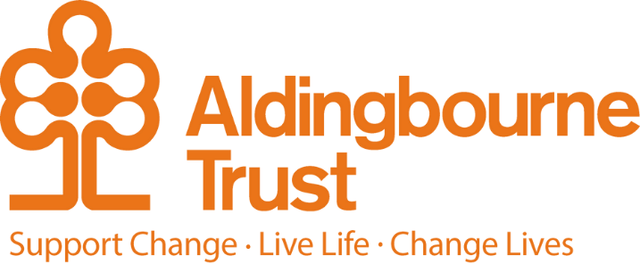

Job Description: Relief Hospitality and Catering Assistant
Project: Aldingbourne Country Centre
Work Location: Aldingbourne Country Centre
Directly responsible to: Hospitality Catering Manager
Overall responsible to: Commercial and Operations Manager

Key Terms and Conditions:
- Hours: Weekends, Bank Holidays and Seasonal periods
- Contracts: Zero hours
- Salary: £8.00-12.71 depending on age and experience

General purpose:

This position is key to the Trust meeting its expectations in delivering our hospitality services to a wide range of external and internal customers. Customer focus is a critical requirement, and the post holder will be responsible for helping to ensure that all catering and events and hospitality services meet these standards.

The Relief Hospitality and Catering Assistant will assist in providing support and appropriate learning environments for people with learning disabilities to provide quality services to all customers, ensuring the highest standards of service are maintained.

The provision of excellent training and commercial success across all enterprises is an essential part of making the Country Centre successful and sustainable.

Duties & Responsibilities:

- Assist the Hospitality Services Manager and Supervisor working with the front of house, cooking and conference teams to provide and maintain the highest of hospitality and conference service standards
- Provide seamless service to our guests, exceeding their expectations and needs
- Provide opportunities for people with learning disabilities to gain skills developing their independence and leading towards employment
- Oversee clients in the safe and appropriate use of equipment, facilities and materials needed to undertake their duties
- Ensure information is communicated effectively, including front of house service, customer liaison, complaints & compliments, other activities and staff on site
- To be mindful of the need to safeguard the Health and Safety of all staff, trainees, volunteers, visitors and others on site and ensure Risk Assessments are completed and reviewed as required
- To ensure that all machinery and equipment is in safe working order regarding the observance of safety regulations and safety procedures under the Health & Safety at Work Act, taking appropriate action, reporting any defects to the line manager.
- Ensure supplies, equipment and work areas conform to required standards and guidelines to maintain 5* Food Standards rating
- Monitor Food & Hygiene practices to ensure required training standards and regulations (e.g., HACCP) are met together with the maintenance of appropriate records
- Ensure environment associated with hospitality is of an appropriate standard e.g., seating, patio areas, wash/toilet facilities
- To operate the tills effectively and account for daily takings
- Ensure stock control, ordering and stock rotation

Any other reasonable duties commensurate with the position as may be specified from time to time by the organisation.

Due to the sensitive nature of the duties, the post-holder will be required to undertake an Enhanced Disclosure in the event of a successful application.

Person Specification

Essential:
- Relevant experience in a Catering environment.
- Self-motivated, with flexible approach.
- Good communication and listening skills.
- Demonstrate the ability to provide excellent customer care.
- Good team working skills.
- Ability to maintain a safe working environment.
- A commitment to the principles of people with learning disabilities having human rights, dignity, respect, equality and an emphasis on positive outcomes for people. An understanding of how to develop arrangements that safeguard and protect people from abuse.

Desirable:
- Food Preparation Qualifications NVQ level 2 or equivalent.

Employee Benefits:

- Employee Assistance Programme
- Bicycle voucher scheme
- Eye care vouchers
- Discounted gym membership
- 10% in ACC shop, ACC café, Horticulture, Make and Make Café.
- Flu Vaccinations
- £200 refer a friend scheme (payable when the new person starts)
- Funded Blue Light Card (1,000’s of discounts)

