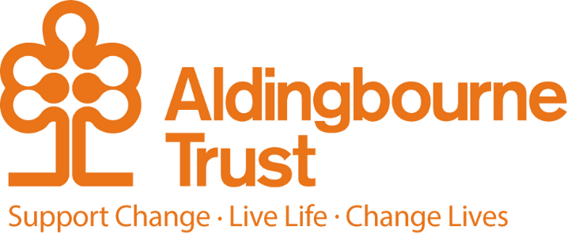

Job Description People Advisor
Project: Central Office
Work Location: Aldingbourne Country Centre

Directly responsible to: Senior People Advisor
Overall responsible to: Chief Executive Officer

General Purpose:
The postholders will support the Head of People and Development in delivering key people projects as outlined by our People Strategy alongside providing an informed, credible, and professional HR advisory service.

Key Terms and Conditions:

- Salary: - £31,000 per annum, pro rata
- Hours of Work: - Full or part-time hours will be considered. Our office hours are 9am to 5pm, Monday to Friday.
- Pension: The Aldingbourne Trust offers a contributory pension scheme to qualifying staff.
- Annual Leave: 25 days each year, pro rata for part-time staff. 1 extra day per annum after 5 years of service, up to a maximum of 5 extra days after 10 years.
- Sick Pay: After the first month’s service, 2 weeks full pay in a rolling 12-month period (pro rata if part time)
- Emergency Family Care Leave: Up to 6 days per annum (pro rata if part time)

Employee Benefits:

- Life Assurance: 2 x your annual salary
- Employee Assistance Programme
- Bicycle voucher scheme
- Eye care vouchers
- Discounted gym membership
- 10% in ACC shop, ACC café, Horticulture, Make and Make Café.
- Flu Vaccinations
- £200 refer a friend scheme (payable when the new person starts)

Duties and Responsibilities:
- To build effective working relationships with managers and teams across the Trust – including the ability to support and coach line managers on the early identification of concerns and effective solutions.
- In agreement and collaboration with the Head of People and Development, to lead on key people projects including being responsible for desired outcomes.
- To utilise People data analytics to identify any concerns, monitor outcomes, and to inform decisions.
- To be champions of the ‘Aldingbourne Way’ and ensuring that our People processes are in keeping with the Trust’s culture and values.
- To lead our wellbeing initiatives including facilitating peer support groups and undertaking wellbeing check-ins with staff.
- To support the People Administrator, including undertaking administrative duties as required such as issuing Contracts of Employment, updating our People database, processing new starters/leavers, and the administration of the monthly payroll.
- To assist the Head of People and Development with the delivery of People training sessions as and when required.
- To provide a proactive, professional, and credible HR advisory service including employee relations work such as absence management, performance management, capability, conflict resolution, disciplinary, and grievance issues.
- To lead on recruitment including liaising with teams and managers on recruitment needs, drafting documentation as required, shortlisting candidates when needed, and assisting project managers with interviews.
- To have an excellent knowledge of UK employment law and other statutory requirements that the Trust must comply with – such as CQC, GDPR and Health & Safety legislation.
- To maintain continuous professional development and a culture of continuous improvement in relation to best practice and improved ways of working.
- To maintain full and thorough confidentiality and to deal with situations sensitively with the required tact and integrity.
- To have a thorough knowledge and understanding of all Trust Policies and Procedures and to support managers in their adherence.
- To attend and actively participate in team and Trust meetings.
- To aid and support the wider Central Office team – including answering the phone, opening and dispensing the post, ordering supplies, filing, and assisting in other departments within the Trust if needed.
- To attend Trust and external events as and when required.
No Job Description can be all encompassing, and you may be required to perform other duties that are not listed but that are commensurate with the post from time to time as requested.
This post will require the postholder to work alongside vulnerable adults and therefore to have the required level of DBS Check.

Person Specification:

Essential:
- CIPD Qualified to Level 5 or above
- Previous People/HR advisory experience
- A proven track record in delivering effective HR interventions
- Excellent communication skills and relationship building capabilities
- Ability to effectively deal with challenging situations
- Excellent interpersonal skills
- Empathetic and personable with a high level of integrity

Desirable:
- Previous experience in the not-for-profit sector or a people-centered organisation

