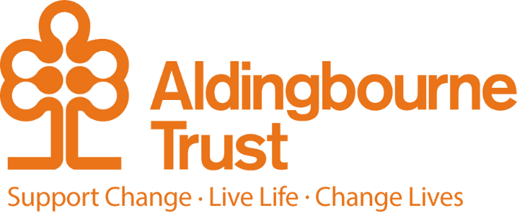

Job Description: Marketing Manager
Project: Central Office
Work Location: Aldingbourne Country Centre, Fontwell
Directly responsible to: COO
Overall responsible to: CEO

General Purpose:
At the heart of this role is a commitment to increasing the Trust’s positive impact on the lives of the people we support. We are looking for a Marketing to lead the development and delivery of an organisation-wide approach to storytelling, audience engagement and sustainable income, ensuring that our work, values and social purpose are clearly understood and widely championed.
This role exists to help secure the long-term sustainability of the Trust. By growing awareness, increasing participation and supporting the generation of income across our charitable and commercial activities, the postholder will enable us to continue delivering meaningful opportunities for the people we support, now and in the future.
You will lead a small, dedicated marketing team and work in collaboration with support colleagues responsible for support services, fundraising, community engagement, social enterprises, the country centre visitor attraction, and the HR team to support the recruitment and retention of colleagues and volunteers.
What Success Looks Like (Key Outcomes & KPIs)
Success in this role will be measured not only by income, but by reach, engagement and values-led impact:
- Sustainable growth in commercial income across the country centre and commercial enterprises including, retail, catering, hospitality, wood, education and events
- Sustainable growth in fundraising income supporting the fundraising team to deliver a calendar of activities, strategy, donor relationships and campaigns
- Increased visitor numbers and engagement at the country centre
- Improved awareness and understanding of the Trust’s work, values and impact among priority audiences
- Strong campaign performance, including recruitment, with learning used to continually improve future activity
- Growing digital engagement, including website traffic, email engagement and social reach

Key Responsibilities:

Purpose-Led Strategy
- Support the development of a values-driven marketing, engagement and income strategy that supports the Trust’s mission and long-term sustainability.
- Ensure marketing activity consistently reflects the Trust’s purpose, values and commitment to the people we support.
- Work in partnership with teams across the organisation to align marketing activity with operational and strategic priorities.

Income Generation & Participation
- Support the delivery of fundraising income targets through effective storytelling, supporter engagement and campaign activity.
- Contribute to the growth of the country centre visitor attraction & commercial enterprises, increasing footfall and participation while enhancing the visitor experience.
- Help maximise income from retail, catering, hospitality, education and events in ways that feel authentic, inclusive and mission-aligned.

Marketing, Communications & Storytelling
- Oversee the planning and delivery of engaging, accessible and inclusive marketing and communications across digital, print and PR channels.
- Lead PR and awareness-raising activity that builds understanding of the Trust’s work and its social impact.
- Ensure internal and external communications are consistent, clear and rooted in lived experience and real outcomes.

Insight, Learning & Improvement
- Ensure robust monitoring of engagement, income and campaign performance.
- Use insight, data and audience feedback to improve reach, relevance and impact.
- Champion the responsible and effective use of systems, data and tools, ensuring compliance with GDPR and best practice.
- Ensure robust project management processes and timelines are established with clear reporting and engagement at all levels.

People, Culture & Collaboration
- Lead, support and develop a motivated and empowered marketing team.
- Build strong, trusting relationships across departments, enabling marketing to support others to achieve shared goals.
- Embed marketing as a collaborative, supportive function that helps colleagues and the people we support to tell their stories with confidence.

Person Specification:

Experience & Skills
- Significant experience in a senior marketing or communications role, ideally within a charity, social enterprise or purpose-led organisation.
- Strong understanding of how marketing and income generation can support long-term social impact.
- Experience in supporting strategy development and delivery.
- Experience delivering multi-channel campaigns that build engagement and trust.
- Confident leader with experience working collaboratively across disciplines across an organisation.
- Experience managing budgets and using insight to guide decision-making.
- Practical experience of digital platforms, CRM systems and tools such as Mailchimp, Canva and content management systems.
- Knowledge of the UK charity or fundraising sector (desirable).

Attributes
- Deep commitment to understanding and representing the needs and voices of the people the Trust supports.
- A confident communicator and leader with strong written and interpersonal skills.
- Thoughtful, creative and solutions-focused, with a calm and flexible approach.
- Highly organised, able to manage competing priorities with care and attention.
- A positive, collaborative leader who models the Trust’s values in everyday work.

Values
- Demonstrates commitment to inclusion, dignity and opportunity.
- Works with integrity, compassion and respect.
- A passion for delivering change, achieving results and collaboration.
- Motivated by social impact and meaningful change.

Key Terms and Conditions:
- Salary £50k per annum depending on experience.
- Hours of work – 35 hours per week, this will include weekend and some evening work.
- Pension: The Aldingbourne Trust offers a contributory pension scheme to qualifying staff.
- Annual leave: 25 days in each year, pro rata for part time staff. 1 extra day per annum after 5 years of service, up to a maximum of 5 extra days after 10 years.
- Sick leave: After the first month’s service, 2 weeks at full pay in a rolling 12-month period (pro rata if Part Time)
- Emergency family care/ career’s leave: Up to 6 days per annum (pro rata if Part Time)

Employee Benefits:

- Life Assurance: 2 x your annual salary
- Employee Assistance Programme
- Bicycle voucher scheme
- Eye care vouchers
- Discounted gym membership
- 10% in ACC shop, ACC café, Horticulture, Make and Make Café.
- Flu Vaccinations
- £200 refer a friend scheme (payable when the new person starts)
- Funded Blue Light Card (1,000’s of discounts)

