
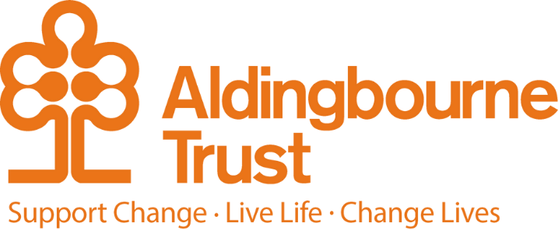

Job Description: Marketing Apprentice
Project: Central Office
Work Location: Aldingbourne Country Centre, Fontwell
Directly responsible to: Senior Marketing Officer
Overall responsible to: COO

General purpose:

As a Marketing Apprentice, you will support the planning, delivery, and evaluation of marketing activities that help raise awareness of the Aldingbourne Trust’s work and impact. You will gain experience across a wide range of marketing channels, including social media, websites, email marketing, events, public relations, and content creation.

Working closely with colleagues across the organisation, you will contribute to campaigns that engage supporters, visitors, donors, partners, and the wider community, while developing valuable skills in research, digital marketing, communications, and campaign analysis.

This role is ideal for someone who is creative, organised, enthusiastic, and interested in building a career within marketing and communications.

We work in an environment of mutual respect, valuing every individual we support, our colleagues, and the wider communities we serve, ensuring that everyone is treated with dignity, compassion, and inclusivity always.

Key Terms and Conditions:

Hours: 35 hours per week, including weekend and some evening work. One day in college.
Contracts: Fixed term contract
Salary: £14,560 per annum
Annual leave: 25 days in each year, which excludes bank holidays.
Sick leave: After the first month's service, 2 weeks at full pay in a rolling 12 month per year

Duties and Responsibilities:

- Support the planning, delivery, and evaluation of marketing campaigns and promotional activities.
- Conduct market, audience, and competitor research using primary and secondary research methods.
- Use research findings and marketing data to support campaign planning and decision-making.
- Create, source, and edit content for digital and offline marketing channels, including websites, email campaigns, social media, promotional materials, and event displays.
- Ensure all marketing communications align with the Aldingbourne Trust’s brand guidelines and values.
- Assist with the management and organisation of marketing assets, images, documents, and promotional materials.
- Publish, monitor, and respond to website and social media content where appropriate.

- Support the promotion and administration of events, fundraising initiatives, community activities, and campaigns.
- Assist with email marketing campaigns and other digital marketing activity.
- Monitor campaign performance, reporting on engagement, reach, and effectiveness.
- Support budget tracking and the monitoring of marketing expenditure in line with organisational procedures.
- Keep up to date with emerging marketing trends, technologies, and best practices.

Person Specification

Essential:
- A genuine interest in marketing, communications, and digital media.
- Must have English and Maths at level 4
- Strong written and verbal communication skills.
- Creative thinking and enthusiasm for content creation.
- Good organisational and time-management skills.
- Willingness to learn new skills and embrace new technologies.
- Positive, approachable, and professional attitude.

Desirable:
- Confidence using Microsoft Office and digital platforms.
- Ability to work collaboratively with a wide range of colleagues and stakeholders.
- Commitment to the values of inclusion, diversity, and community engagement.
- Previous marketing experience is not required as full training and support will be provided.

Employee Benefits:

- Life Assurance: 2 x your annual salary
- Employee Assistance Programme
- Bicycle voucher scheme
- Eye care vouchers
- Discounted gym membership
- 10% in ACC shop, ACC café, Horticulture, Make and Make Café.
- Flu Vaccinations
- £200 refer a friend scheme (payable when the new person starts)
- Funded Blue Light Card (1,000’s of discounts)

Document control
Prepared for | Internal review
Status | Draft for HR / manager review
Version | V1
Date | 15 July 2026

