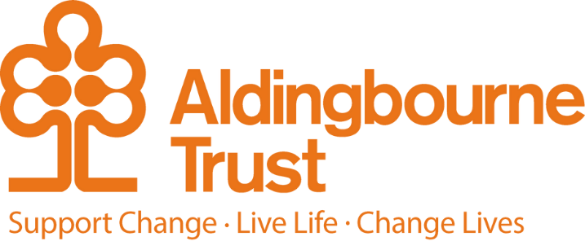

Job Description – Comminity Support Worker

Project: MAKE@Aldingbourne Enterprises

Work Location: MAKE – Fratton, Portsmouth

Directly responsible to: Manager, MAKE

Overall responsible to: Deputy CEO, Aldingbourne Trust

**General Purpose:**

To support adults with learning disabilities to develop skills, confidence, and independence through meaningful community-based opportunities. These may include work experience, volunteering, gardening, event planning, creative projects, sports, and social activities. The Support Worker will enable individuals to engage actively in their community, pursue personal goals, and build pathways toward greater independence and wellbeing.

**Key Terms and Conditions:**

* Hours of work – 32 hours per week across 5 days (Monday – Thursday. 9:30 – 16:30 (30 min break) 6.5 hr day - Friday 9.30 - 16:00 (30 min break) 6hr day.)
* We would expect you to be a team player and maybe asked to work one Saturday each month. There are occasions when we would ask you to work an occasional Sunday or evening for special events with prior notice.

**Key Responsibilities**

* Person-Centered Support: Provide individualised support based on each person’s needs, goals, and abilities, promoting independence and self-confidence.
* Community Involvement: Facilitate participation in community activities such as work placements, volunteering roles, local events, gardening projects, sports, and creative initiatives.
* Skill Development: Support individuals to develop practical, social, and communication skills that enhance employability, wellbeing, and community engagement.
* Partnership Working: Build positive relationships with community organisations, employers, and local groups to create inclusive opportunities.
* Skills towards work. Planning activities which give skills towards paid work and employment opportunities.
* Activity Planning: Contribute to the design and delivery of varied, engaging, and inclusive activities both within the service and in the wider community.
* Safeguarding and Wellbeing: Ensure the safety, dignity, and wellbeing of all individuals at all times, following safeguarding policies and promoting positive risk-taking.
* Documentation and Reporting: Maintain accurate records of support provided, progress achieved, and any incidents or changes in individual circumstances.
* Team Collaboration: Work as part of a supportive and dynamic team, contributing ideas, sharing best practice, and maintaining a positive environment.
* Advocacy: Empower individuals to express their choices, make informed decisions, and have their voices heard in all aspects of their lives.

**Essential:**

* Experience supporting adults with learning disabilities or other additional needs.
* Ability to travel with the people we support.
* Able to connect with the wider community.
* Commitment to person-centred values and inclusion.
* Excellent communication and interpersonal skills.
* Ability to encourage and motivate others.
* Flexibility to work across various community settings.
* Reliable, proactive, and compassionate approach.
* Good IT and record-keeping skills.
* Can Do attitude
* Desirable:
* Knowledge of local community resources and organisations.
* Experience in areas such as employment support, gardening, event coordination, or sports facilitation.
* Full UK driving licence (business insurance is essential)
* Relevant qualification in Health & Social Care (or willingness to work towards one).

**Person Specification:**

**Essential:**

* Experience of working in a creative environment or evidence of how creative you are and what skills you can offer.
* Ability to research ideas on online platforms such as Pinterest to create innovative saleable products from recycled materials or at a low cost.
* Ability to take initiative and work alone and in a team.
* Confidence to support a diverse group of people who have a learning disability and / or autism.
* Strong communication and listening skills.
* Good planning and organizing skills.
* Good literacy, numeracy, and IT skills.

**Additional:**

* You will be required to complete any other reasonable duties commensurate with the post. Such as prompt the people we support to wear protective clothing or responding to someone who maybe sick or needs help with medical assistance.
* You may be asked to drive the people we support or colleagues to training, activities and events in the community. Business insurance is required for this element of the role.
* This post is a regulated activity. As the post holder, you will be expected to undertake a DBS check, at enhanced level and against the Adult Barring List. Regulated activity (adults) as defined by the Safeguarding Vulnerable Adults Groups Act 2006 from 10th September 2012, for the purposes of this post are: providing personal care, assistance with general household matters, conveying people.  We have assessed this post and are satisfied that it is reasonable and likely that the post holder will be required to engage in any or all of these regulated activities.

**October 2025**