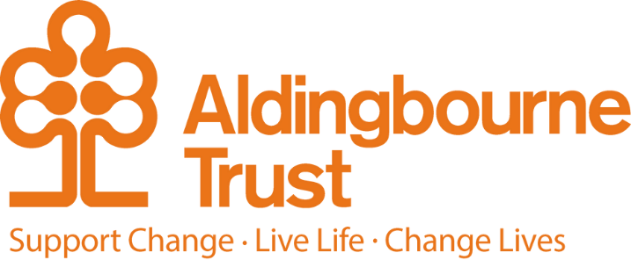

Job Description and Person Specification – Connect to Work Adviser

Project: Connect to Work

Work Location: West Sussex

Directly responsible to: Julia Pascoe

Overall responsible to: Martin Ford

**General Purpose:**

Connect to Work is a national, government-funded initiative and part of the Get Britain Working Strategy. 43 clusters of local authorities will be offered grants to deliver a high-fidelity Supported Employment programme, including the West Sussex, Brighton and Hove Delivery Area.

As part of this, Connect to Work has been launched in West Sussex. This is a work programme to help disabled people, those with complex health conditions and people with complex barriers to employment, to find sustainable work.

Working within the Aldingbourne Trusts Connect to Work Employment Programme, the role will include managing a caseload of eligible people to assist them in securing sustainable paid employment in line with their preferences; also supporting eligible people with job retention.

You will be at the heart of delivering the service, working with a caseload of participants and with local employers, provide information, advice, guidance, support, and help people move into meaningful employment.

**Key Terms and Conditions:**

* Hours of work – 37.5 per week Monday to Friday

**Duties and Responsibilities:**

* Build trusting relationships with clients, motivating and empowering them to take ownership of their employment journey.
* Conduct comprehensive assessments, including needs analysis and vocational profiling, to tailor support to each participant.
* Provide person-centred support, encouraging sustainable progress and addressing challenges constructively.
* Coach participants in developing job-seeking strategies, improving CVs, building interview skills and supporting the development of work-related skills.
* Advocate for the benefits of recruiting a diverse workforce with local employers, using a strong understanding of the local labour market.
* Build and maintain partnerships with employers, predominantly from small- and medium-sized businesses, and build opportunities for your clients.
* Identify, and help to secure, competitive job opportunities that align with participants' aspirations, including accessing jobs that are not advertised.
* Provide employers with advice on creating inclusive workplaces, implementing reasonable adjustments and accessing Access to Work funding.
* Conduct job analyses to ensure participants’ roles and environments are well suited to their needs.
* Provide ongoing support to participants and employers to address challenges, including advocating for adjustments and accommodations.
* Collaborate closely with other support services (such as third sector organisations) to ensure participants are receiving integrated, holistic support.
* Responsible for small expenditures from an agreed budget when appropriate, for example, making necessary purchases in relation to situations arising with people who access or need the service.
* Maintain accurate, confidential records, ensuring all data complies with GDPR, organisational and programme standards.
* Participate in training, professional development and team activities to ensure continuous improvement.

**Person Specification:**

**Qualifications**

**Desirable**

* Relevant qualifications (e.g. IAG, Social Welfare, Communication or Social Care).

**Knowledge and experience**

**Essential**

* Strong employer engagements skills to support job search activities, with experience of employability, employment support and supporting people with barriers, especially those with learning disabilities/autism/neurodivergence.
* Experience of working with vulnerable adults
* Excellent IT skills – be able to use customer databases as well as being proficient in Microsoft Excel and Word and online communication platforms (including Teams).

**Desirable**

* Experience of using and/or understanding of Individual Placement Support (IPS) and/or Supported Employment Quality Framework (SEQF)
* Experience of using a coaching model to support a cohort of clients.
* Familiarity with and understanding of Access to Work, reasonable adjustments and the commercial constraints of local employers.

**Key Skills**

**Essential**

* Strong organisational skills, including prioritising demands and maintaining contact with people supported by the service.
* Ability to use assessment processes and to manage risk with people who may have complex needs and barriers.
* Excellent communication skills including interpersonal and written skills with experience of writing reports and letters.
* Emotional intelligence and the ability to empathise with, build and maintain rapport with people with significant barriers.
* Tenacity, resilience and resourcefulness – the ability to overcome challenging situations and find alternative solutions.
* Flexible (not a 9-5pm job) with some out of hours work required.
* Knowledge of the local labour market.

**Additional requirements**

**Essential**

* Due to the diversity of our customer base, the need for regular one to one meetings and the flexibility required to deliver our contracts,
* An enhanced DBS Check will be required.
* A commitment to promoting equality, diversity and inclusivity in all aspects of work.
* Driving License and use of a car for business travel is desirable - this is because you will be regularly visiting employers, to carry out employment engagement, in work support and on occasion to accompany people to interviews.

**Date**

* August 2025