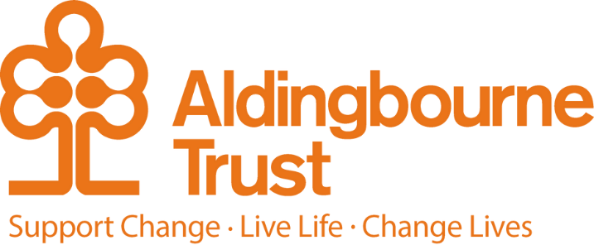

Job Description – Autism Consultant LIMA

Project: LIMA – Low Intensity Management for Autism

Work Location: Home Based

Directly responsible to: Martin Ford

Overall responsible to: Lu Dash

**General Purpose:**

To work within the LIMA (Low Intensity Management for Autism) team to work in a low intensity management approach with adults around issues relating to people’s autism spectrum condition, providing timely and easily accessible support, signposting to other services and drawing on experience in autism to identify people who may be in need of more formal, therapeutic or social care support.

Your support will focus on post-diagnostic and social skills that covers specific issues faced by customers with autism, such as negative social experiences, the need to clarify social experiences, ways of promoting independence, help to develop coping strategies and to act as a sounding-board for people that may not have family or friends they feel able to confide in. You may signpost people to appropriate autism-friendly community-based support, based on our team’s knowledge and expertise. You may also provide guidance to mainstream services on how they can support people who have autism.

LIMA offers group, individual, online and telephone support. The role involves home working and possibility of some face to face sessions.

**Key Terms and Conditions:**

* 20 hours per month (work pattern to be confirmed at interview).
* Salary £4,328.06 per annum.

**Duties and Responsibilities:**

* To support and deliver autism-specific psycho-education to people, tailored to individual needs.
* To discuss clients in peer supervision.n
* Where applicable to inform clients’ GPs of any mental health risks.
* Maintain databases regarding KPI measures required for West Sussex County Council commissioners in collaboration with other team member.
* To demonstrate effective time management by keeping accurate records to show economic use of time and resources, diary appointments and workload.
* To maintain accurate and up to date documentation of records on people, in line with Alongside Autism Policies and other legislative requirements.
* To follow service administration systems, submitting statistical and data information as required (i.e. meeting report deadlines for funding bodies).
* To signpost people to other agencies and resources.
* To assess mental health and other risks, signposting or referring to appropriate agencies.
* Communicate with external organisations and Aldingbourne Trust projects.
* To contribute positively to the effectiveness and efficiency of the LIMA project.
* To be responsible for practicing within competence.
* To undertake regular supervision and attend any mandatory or CPD training as required to fulfil the job role and within budget constraints.
* To fully participate in performance review and personal development planning process on an annual basis.
* To achieve and demonstrate agreed standards of personal and professional development within agreed timescales.
* To use initiative in exploring new approaches and to think outside the box.
* To perform any other duties that are commensurate with the post and may be specified from time to time by the organisation.
* This post is a regulated activity. As the post holder, you will be expected to undertake a DBS check, at enhanced level and against the Adult Barring List. Regulated activity (adults) as defined by the Safeguarding Vulnerable Adults Groups Act 2006 from 10th September 2012, for the purposes of this post are: assistance with general household matters, conveying people. We have assessed this post and are satisfied that it is reasonable and likely that the post holder will be required to engage in any or all of these regulated activities.
* All staff will have a sound awareness of Safeguarding issues and be clear about their respective roles and responsibilities to report, respond to and share information in relation to Safeguarding Adults, Safeguarding Children, Domestic Abuse and Public Protection.
* All staff will have knowledge of and adhere to the Data Protection Act and will not disclose to any person or organisation, any confidential information that comes into their possession in the course of their employment – unless there is an overriding legal duty to do so.

**Person Specification:**

**Essential:**

* Extensive experience of working with Adults with ASD.
* Level 4/Diploma/Degree level qualification relevant to supporting people who have autism.
* Post qualification experience including significant experience of people with ASDs in the non-learning-disabled population.
* Experience of monitoring and managing own caseload.
* Experience in identifying psychosocial and practical interventions and provide appropriate signposting of services and give guidance to others on signposting.
* Detailed knowledge and understanding of the complex psychological, psychiatric and communicative function associated with ASD.
* Have an understanding and demonstrate independent ability to assess risk and follow safeguarding procedures.
* Demonstrate flexibility and the ability to manage and respond appropriately to competing priorities.
* Ability to work within a team or on own initiative analyse risk and respond appropriately.
* Time management skills and ability to prioritise workload.
* Competent in the use of the required information technology.
* Ability to facilitate and implement change.
* Apply sound critical appraisal skills in practice.
* Ability to maintain KPI databases and use other computer-based technology to a competent level i.e. Microsoft Office Suite, internet, etc.
* Ability to act independently on a day to day basis.
* Ability to work across multiple sites and via video conferencing, telephone, social media applications (eg, Microsoft Teams, zoom, What’s App.)
* Car driver and regular use of a car, with the ability to travel in West Sussex.

**Desirable:**

* Post Graduate Qualification relevant to adult ASD i.e. Post Graduate Diploma in Autism or Applied Behaviour Analysis.
* Appropriate professional registration (if core profession i.e. NMC)/ or accreditation to a suitable regulatory body, relevant to working with individuals with ASD, eg UK-SBA, or evidence of extensive clinical experience working with people with ASD.
* Experience and ability to independently compile and write complex neurodevelopment reports.