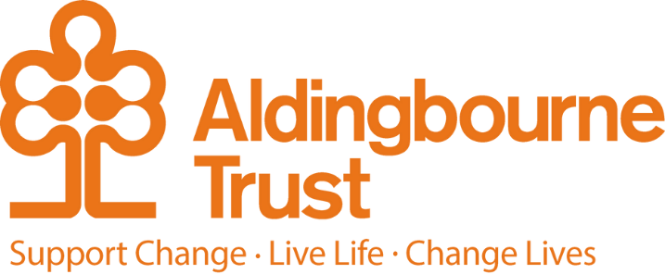

Job Description -Support Workers
Project: Transitions
Work Location: Bognor Regis

Directly responsible to: Manager, Transitions Support Services
Overall responsible to: The Managing Director, Aldingbourne Trust

We invite you to join our Supported Living team that….

Works alongside people so that they can live their life with confidence and freedom. We work to make a difference, and to finish each day knowing our time counted. We work alongside people to ensure they are respected and protected but are challenged to push their own boundaries and that our teams challenge themselves to try new things and different ways of working. Our work is led by the people we support, not just in practical ways such as help to manage their home and lives, but to support their growth and connections as individuals in their community. If you are looking for job where you are encouraged to share your skills and talents, to question and be curious, to work alongside people to grow and see others grow, then please read on.

Qualities we are looking for:

We work alongside people from all different age groups, social backgrounds, and diversity - we are looking for staff who share the same diversity of background, age, and experience. There is no ideal description of who you must be, other than someone who is interested in the wellbeing of others (your team and people you support), who can listen and collaborate (we don’t tell people how to live their lives, we support them to make good life choices), who is caring, committed, and a team player

Things you will be expected to do as part of your work:

Support people with their daily routines – where people have specific routines or personalised support, you will receive full training to be able to do this safely and with confidence. To build your knowledge of key legal frameworks such as the Human Rights Act, the Care Act, and CQC regulation. To be committed to your own development and the development of your team – this could include working towards a sector recognised qualification, undertaking training in a specific area of interest that you or someone you support has, or working with your team to tackle a challenge or support your colleagues to develop their skills and experience. Depending on the role you may also be required to: drive a vehicle, dispense medication, take part in an on-call rota, or go on holiday with the people we support.

What our team members say about us

“I work in a job that supports people. Every day the People I support make me smile, they make me laugh. Every day is different and brings new challenges – challenge accepted!

My job is to make sure that people have their voice heard and provide ways for them to socialise and make friends as well as develop, feel valued, have meaning and have fun.

We help each other to make positive changes and stand up for basic human rights. As with any job, there is the usual administrative things that need to be done, but most of the time is about creating relationships and changing lives on a personal level. My work does not feel like work but more like a lifestyle as well as a second giant family. I work in social care.” (Casper Beade Rioseco, Community Solutions & Co-production Manager)

“When people think of social care work, I think it’s quite common to picture swelteringly hot care homes with people in tabards bustling from room to room with trays of food, mobility aids, piles of laundry and reams of paperwork. My job couldn’t be further from that! I visit people who are living independently in their own homes and first on the agenda every time is a nice chat to see how they’re doing; I’m always asked how I’m doing too, and we have a good catch up.” (Kate Blunden, Residential Support Worker)

“I know for myself I originally applied 6 years ago because the advert said the line ‘do you believe people with learning disabilities should have equal opportunities in the community?’ - I didn’t really read the details it was that line that made me go yeah, yeah I do… and the rest is history!” (Lauren Floyd, Senior Relief Worker)

What the people we support value in our team members:

