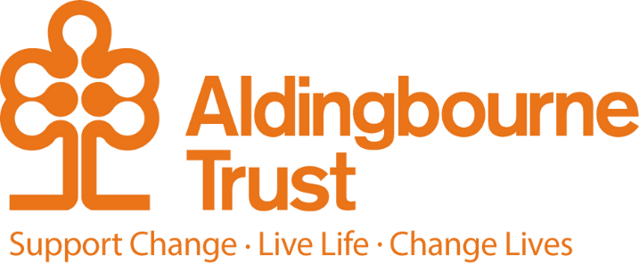

Job Description: Supported Living Manager
Project: 36 Sudley Road & Queens Square
Work Location: Bognor Regis
Directly responsible to: Operations Manager, The Aldingbourne Trust
Overall responsible to: COO, The Aldingbourne Trust

We invite you to join our team of passionate people working at Sudley Road and Queens Square. Our team supports people with a lived experience of learning disabilities and autism to live the lives of their choosing. Our team are founding members of the Gr8 Support Movement (www.paradigm.co.uk) and we are passionate about our work. We are looking for someone to work alongside us, to inspire us and support us to be the best we possibly can.
Within Aldingbourne we have been working towards our teams becoming self-organising. A key element to this role will be to work with the team to support them in developing a team culture that thrives on accountability, continuous improvement, and taking ownership of tasks.

The service is based across two sites within walking distance of each other. The main site includes ten self-contained flats, along with an office. A second site, located nearby, consists of six self-contained flats.

You will lead and support a busy staff team to provide high-quality, consistent, and person- lead support. This includes creating a positive team culture, making sure people receive the right support at the right time, and ensuring the service is safe, well-run and focuses on helping people live full and meaningful lives.

We are committed to growing our supported living services in the future, which may lead to the development and expansion of this service. We are therefore looking for someone who is resilient, open to change and able to adapt positively, while continuing to provide strong and consistent leadership for both people who live in the service and the staff team.

Our vision and purpose:

- To support people the best way we can to live an authentic life of their choosing.
- To champion the rights of people we support
- To support one another to achieve our shared goals
- Promoting independence at every opportunity
- All staff working in a consistent manner to support people reach their full potential

What you will get from working with us

- An appreciation of working in a team that believes in its purpose and is supported by the wider Trust.
- An opportunity to deepen knowledge and learning in areas that are of interest and support the purpose of the team.
- A climate where decision making is based on open conversations and appreciation of all information with everyone’s views being actively sought.
- Getting to know the people we support, their families and investing in their wellbeing and future

Duties and Responsibilities:

- Work as part of Aldingbourne Management Team to share good practice and develop resilience amongst other managers and their teams.
- Understand & actively support the Trust's values, aims & policies through your own actions.
- Support people to ensure key areas of the life, like their home and its maintenance /repairs are reported and actions agreed within reasonable timeframes. Ensure KPI’s in this area are maintained by the landlord/ housing provider.
- Ensure all staff are supported formally (supervisions, meetings and appraisals) and informally to meet their professional and emotional support needs.
- Encourage the people we support to be involved in making decisions and giving feedback about the services they receive.
- Assist and support people to be in as much control as possible over their lives and actively seek to identify appropriate external agents to assist people whenever needed – such as health, wellbeing and emotional support.
- Manage the complaints process and use lessons learned to improve services and ensure that there is not a blame culture but a culture of responsibility and accountability across the team.
- Always looking to the future - what can we do to support further independence and personal growth?
- Work with people we support and their families to identify ways in which they would like their life to change, pushing boundaries and not accepting limitations until everything has been fully explored.
- Challenge staff by encouraging them to think differently – without breaking the law or putting themselves or others at unacceptable risk.
- To maintain knowledge and research information concerning CQC and other social care related legislation such as Mental Capacity Act, The Care Act, and Adult Social Care Green Paper
- To ensure that best practice models like Valuing People & Reach Standards are not lost to the day to day demands of the service.
- Question decisions made by funding authorities where it is believed they have failed to discharge their full responsibilities to people as detailed by the Care Act 2014.
- To ensure that the voices of people being supported are heard and can influence decisions not just at Sudley Road/Queens Square across the Trust.
- Encourage staff to reflect on their own qualities and how these can align to Gr8 Support; celebrate resourcefulness and creativity not just ability to follow instructions.

Actively listen to the people we support and their views and wishes, mindful that some people and their families, will not always agree with one another.
- Be reassuring but realistic; do not over promise and under-deliver.
- To actively manage your team, and (develop) maintain a sense of shared responsibility and psychological safety within the team, for one another and the people we support.
- To ensure new and existing staff members have active CPD (continuing professional development) that not only ensures your service is legally compliant but also stretches staff and builds upon relevant interests or skills they wish to develop.
- Support the staff team in developing their sense of responsibility within their workplace and daily duties.
- Awareness of disability barriers and how these might impact on people we support, their families and carers.
- Recognise the importance of equality and inclusion in the way you work, ensuring the individual’s needs are central to your work,
- Ensuring people with learning disabilities understand their rights and responsibilities and are supported to undertake an active role in making decisions.
- To be familiar with and implement the principles of social inclusion, promoting independence and progression.
- Challenge complacency and poor performance
- Support people to have their voice heard, challenge or complain where appropriate
- Report to the appropriate authority (via safeguarding) any concerns in relation to abuse with regards to a vulnerable person.
- Provide written information to people we support that is accessible (if needed) and make reasonable adjustments to your work such as meeting venues, times of meetings, length etc that reflect the needs of person being supported.
- Chair regular staff meetings and encourage the staff team to share their thoughts and feelings on topics raised in a respectful manner.

Key Terms and Conditions:
- Salary: £34,747.83
- Type of contract: Permanent
- Hours of work: 37.5 hours per week
- Pension: The Aldingbourne Trust offers a contributory pension scheme
- Annual leave: 33 days in each year including Bank Holidays, pro rata for part-time staff. 1 extra day per annum after 5 years of service, up to a maximum of 5 extra days after 10 years.
- Sick leave: After the first month’s service, 2 weeks at full pay in a rolling 12- month period pro rata for part time staff.
- Emergency family care/career’s leave: Up to 6 days per annum pro rata for part time staff.

Employee Benefits:

- Life Assurance: 2 x your annual salary
- Employee Assistance Programme
- Bicycle voucher scheme
- Eye care vouchers
- Discounted gym membership
- 10% discount in ACC shop, ACC café, Horticulture, Make and Make Café.
- Free admission to ACC (Family of 4 with member of staff present)
- Flu Vaccinations
- £200 refer a friend scheme (payable when the new person starts)

