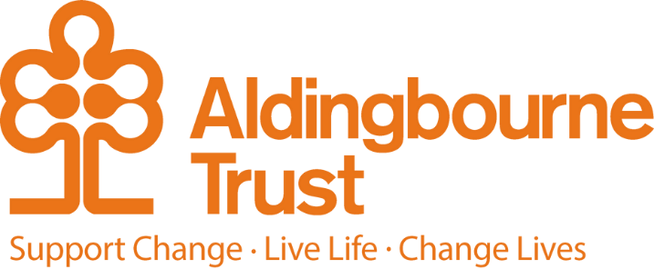

Job Description: Relief Open Farm Support
Project: Aldingbourne Trust
Work Location: Fontwell
Directly responsible to: Open Farm Manager
Overall responsible to: Commercial and Operations Manager

General purpose:

This is a key post within the Open Farm team, you are responsible for maintaining the Farm as a visitor attraction and for providing vocational training for our client group.
We are passionate about helping the people we support to improve their well-being, quality of life and workplace skills. People are supported to assist with all the regular tasks on the Farm, in order to gain skills and experience to help them achieve independence and lead fulfilling lives.
The Relief Open Farm Support will ensure that the welfare of the Farm’s animals is always maintained to a high standard. Daily jobs include feeding, cleaning, performing health checks and providing enrichment for the animals. The nature of the work is very physical and takes place in all weather conditions, so your general fitness and ability to work as part of a team throughout the year is of importance.

In this role you will support the Open Farm Team and be required to ensure that visitors are always provided with an excellent level of customer service. You will be on hand to provide information about the various animals, answer any questions and participate in the daily activities.

Due to the nature of this role, regular weekend working is required including public holidays. Rotas will be agreed on a monthly rolling basis.

Key Terms and Conditions:
- Hours: Flexible working over the week, weekends and bank holidays, various hours in the day.
- Contracts: Zero hours
- Salary: £8 - £12.71 depending on age
- Sick leave: After the first month's service, 2 weeks at full pay based on hours you have worked over the last 12 weeks

Person Specification:
- Building & maintaining positive working relationships with customers
- Ensure customers are clear about expectations
- Ensure excellent communication takes place with customers & staff
- Identify & manage any conflict, deal with any concerns/complaints in a professional &
- timely manner
- To ensure the health and safety of the clients, staff and visitors to the Open Farm is maintained and ensure appropriate Risk Assessments are maintained for the area.
- To support people who have a learning disability to operate an Open Farm as a visitor attraction at the Centre.
- To ensure and maintain the health and wellbeing of all livestock and meet statutory requirements and legal obligations under the guidance of the Open Farm Manager.
- To ensure animal and food waste is properly disposed of to minimise risk of infection, infestation and environmental contamination.
- Ensure the visitor and operational washing facilities are clean and stocked.
- To ensure that all machinery and equipment is in safe working order regarding the observance of safety regulations and safety procedures under the Health & Safety at Work Act, reporting any defects to the Manager.
- To ensure that any medication, chemicals or substances are safely stored and that appropriate COSHH records are maintained.
- Respond to requests for information/clarification from colleagues & customers.
- To fully engage with our Visitors to ensure they have a safe, enjoyable and informative visit to the Open Farm.
- To participate in staff meetings, training courses and seminars.
- Working proactively & supportively with the Open Farm Team to meet the needs of the Open Farm.
- Provide opportunities for people with learning disabilities to gain skills developing their independence and leading towards employment
- Coach clients to provide excellent customer service, leading by example.
- Ensure you maintain a programme of continuing professional development.

Essential:

- Due to the location of the Centre, own transport is essential.
- Able and willing to work weekends and public holidays (including Christmas) subject to agreed rotas.
- Demonstrate the ability to provide excellent customer care.
- Excellent organisational, communication and team working skills.
- Ability to maintain a safe working environment.
- Self-motivated, able to demonstrate a desire for self-development.

Desirable:
- Relevant experience of animal husbandry.

Employee Benefits:

- Employee Assistance Programme
- Bicycle voucher scheme
- Eye care vouchers
- Discounted gym membership
- 10% in ACC shop, ACC café, Horticulture, Make and Make Café.
- Flu Vaccinations
- £200 refer a friend scheme (payable when the new person starts)
- Funded Blue Light Card (1,000’s of discounts)

DBS and safer recruitment
This role requires an Enhanced DBS check as instructed.

