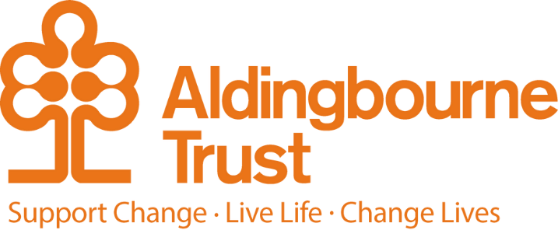

Job Description: Senior Female Support Worker
Project: ISS
Work Location: Felpham, Bognor Regis
Directly responsible to: Manager
Overall responsible to: Head of Support

General Purpose:

We are seeking a Senior Female Support workers to join our team for 2 ladies we support based in the Felpham, Bognor Regis area.

The holders of this key post within the Aldingbourne Trust are responsible for enabling our tenants to live the lives they choose safely, while developing their own independence. As a Senior Support Worker you will role model excellent support for our tenants, and deputise for the Manager in their absence.
You are expected to meet the requirements of the Care Standards Act and Regulations, ensuring your work meets the standards set out by the Care Quality Commission and other legal requirements including the West Sussex Safeguarding and Medication policies.
You will work as part of a team with staff and tenants to ensure that the emotional, social, medical and material needs of the tenants are recognised, assessed and met.

This role requires that you are available to work as part of a rota as well as carry out any sleep-in duties.

Key Terms and Conditions:
- Hours of work – Full or Part Time Hours
- Pension: The Aldingbourne Trust offers a contributory pension scheme to qualifying staff.
- Annual leave: 25 days in each year, pro rata for part time staff. 1 extra day per annum after 5 years of service, up to a maximum of 5 extra days after 10 years.
- Sick leave: After the first month’s service, 2 weeks at full pay in a rolling 12-month period (pro rata if Part Time)
- Emergency family care/ career’s leave: Up to 6 days per annum (pro rata if Part Time)

Employee Benefits:

- Life Assurance: 2 x your annual salary
- Employee Assistance Programme
- Bicycle voucher scheme
- Eye care vouchers

- Discounted gym membership
- 10% staff discount at Seasons Nursery (based at Aldingbourne Country Centre)
- 10% in ACC shop, ACC café, Horticulture, MAKE, and MAKE Café.
- Peer Support Groups – Menopause Support, Mental Health First Aid, and Neurodiversity
- Staff and volunteer awards
- Qualify for the national Blue Light Card discount scheme
- £200 refer a friend scheme (payable when the new person starts)

Duties and Responsibilities:
- To work alone and as a team with staff / tenants to ensure that the emotional, medical and material needs of the tenants are recognised, assessed and met.
- To liaise with the Manager as required and ensure efficient handover.
- Promote relationships which enable tenants to integrate into the life of their community and ensure assistance is provided where needed.
- Promote opportunities and engagement based on peoples’ person-centred plans.
- Promote healthy lifestyles and wellbeing, ensuring access to community and specialist health services.
- To attend and represent the Project at meetings both external and internal to the Aldingbourne Trust.
- Encourage tenants to be involved in making decisions and giving feedback about the services they receive.
- Promote relationships which enable each tenant to integrate into the local community, providing support where required.
- To liaise effectively with families, carers and significant others as appropriate.
- To effectively participate in staff meetings, training courses and seminars, including service reviews, meeting Skills for Care specifications and updating knowledge, skills and competence.
- Work as part of the rota, carrying out sleep-ins and on call duties as required.
Supervisor
- To deputise for the Manager as and when required, e.g. organise rotas, keep staff sickness/holiday records etc.
- Treat each individual with dignity and respect, ensuring their confidentiality is maintained.
- Assist tenants in their daily routines such as cooking, shopping, housework etc
- Take responsibility for accurate and timely record keeping and administration
- Ensure support plans are comprehensive and up to date.
- Give tenants help and advice to manage their budgets, pay bills and spend their own money.
- Assist and support tenants with personal care, which can range from prompting to physical assistance (e.g. bathing, hair washing, shaving and where appropriate incontinence). Tenants may need support with stoma care, cream application, and support with diabetes.
- Assist and support tenants with their health and medication needs for instance by prompting or administering medication or assisting tenants to attend routine appointments (e.g. chiropodist, dentist, GP).
- Effectively participate in staff meetings, training courses and seminars.
- To ensure that relevant information is recorded and communicated effectively.
- To provide administration support to the Manager.
- Meet the Common Induction Standards within your first three months of employment, then ensure compliance training (Health & Safety, Infection Control, Fire, Health & Safety and Medication) is kept up to date.
Person Specification:

- Recognise and implement safeguarding procedures to protect tenants, which includes whistleblowing when appropriate.
- Taking personal responsibility for your personal health and safety, and that of your tenants by implementing health and safety procedures, including pro-actively reporting issues and potential hazards.
- Contribute to new ideas & projects to achieve successful implementation
- Ability to step out of comfort zone, to explore & consider innovative approaches to meet the Trust’s objectives (for example new IT packages)
- Promote the Aldingbourne Trust as an employer and service provider of choice
- In partnership with the tenant, to formulate and implement person centred assessments and care plans.
- In partnership with the tenant, to offer support and assistance with their personal plans and choices, e.g. social and recreational activities, medical appointments etc.
- To supervise and appraise staff and liaise with the Manager regarding staff development and support.

- To work effectively with the Project Manager in reviewing, planning and developing the service.
- To encourage peer support – enabling people to support themselves in pairs or groups.
- Ensure excellent communication takes place with tenants, staff, parents & carers and care professionals, ensuring the interests of the individual are your primary concern.
- Identify & manage any conflict, deal with any concerns/complaints in a professional & timely manner.
- Recognise the importance of equality and inclusion in the way you work, ensuring the individual’s needs are central to your work, rather than your own.

Additional:

- You will be required to complete any other reasonable duties commensurate with the post.
- This post is a regulated activity.
- As the post holder, you will be expected to undertake a DBS check, at enhanced level and against the Adult Barring List. Regulated activity (adults) as defined by the Safeguarding Vulnerable Adults Groups Act 2006 from 10th September 2012, for the purposes of this post are: providing personal care, assistance with general household matters, conveying people. We have assessed this post and are satisfied that it is reasonable and likely that the post holder will be required to engage in any or all of these regulated activities.

