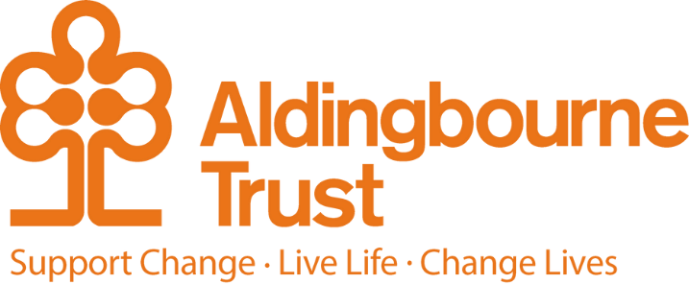

Job Description – Sleep-in female Support Workers
Project: Individualised Support Services
Work Location: Felpham/Bognor Regis

Directly responsible to: Manager, Individualised Support Services
Overall responsible to: The Managing Director, Aldingbourne Trust

General Purpose:
We are looking for female support workers who can assist with the sleep-in cover for our project located in Felpham. The project aims to provide one-on-one support to a lady with profound learning disabilities and complex needs. You will be responsible for personal care tasks and household support as a support worker.
We welcome applications from people with prior experience in working with autism. A positive attitude would be preferred for this role.
This work requires working at night on weekdays and weekends. The sleep cover will start at 9 pm and end at 6 am the following morning, with an 8 am finish for the overall shift.

Terms and Conditions: Support Worker
- Salary: £12 hourly rate
- Sleep in payments- £58.65/sleep
- Pension: The Aldingbourne Trust offers a contributory pension scheme
- Counselling Service
- Bicycle voucher scheme

Duties and Responsibilities:
- Work in partnership with each person to offer support and assistance with personal planning and choices.
- Work as part of the team on a rota, carrying out sleep-ins and on-call duties as required.
- Effectively participate in staff meetings, training courses and seminars.
- Ensure excellent communication takes place within your team, with the people we support, staff, parents & carers and care professionals, ensuring the interests of the individual are your primary concern.
- Promote opportunities and engagement based on peoples’ person-centred plans.

- Promote healthy lifestyles and wellbeing, ensuring access to community and specialist health services.
- Ensure you maintain a programme of continuing professional development.
- Understand & actively support the Trust's values, aims & policies through your own actions.
- Encourage the people we support to be involved in making decisions and giving feedback about the services they receive.
- Assist and support people with their health and medication needs for instance by prompting or administering medication or assisting the people we support to attend routine appointments (e.g. chiropodist, dentist, GP).
- Encourage the people we support to participate in all activities of their daily lives, taking every possible opportunity for meaningful activity.

Person Specification:

Essential:

- The ability to communicate clearly.
- Listening skills.
- Administrative/organisational skills.
- Team player.
- Able to use own initiative.
- Minimum Age 18.
- Female applications only
- A commitment to the principles of people with learning disabilities having human rights, dignity, respect, equality and an emphasis on positive outcomes for people. An understanding of how to develop arrangements that safeguard and protect people from abuse.

Desirable:

- Experience of supporting people who have a learning disability.
- Computer literate
- Driving license

