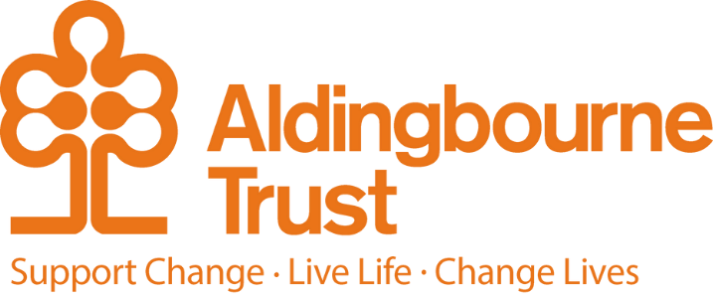

Job Description – Deputy Manager, Milton Lodge
Project: Milton Lodge
Work Location: Milton Lodge, Bognor Regis

Directly responsible to: Manager, Milton Lodge
Overall responsible to: The Managing Director, Aldingbourne Trust

General Purpose:

The Deputy Manager is responsible for working with the Project Manager to manage and develop Milton Lodge, enabling its tenants to safely live the lives they choose, while developing their own independence.

You are expected to help Milton Lodge meet the requirements of the Care Standards Act and Regulations, ensuring the services meet the standards set out by the Care Quality Commission and other legal requirements including West Sussex Safeguarding and Medication policies.

To do this you will manage and work as a team with staff, tenants, care and other agencies to ensure that the emotional, medical and material needs of tenants are recognised, assessed and met and to enable each tenant to achieve their full potential. The post holder will be required to work some shift work and this will be over a 7 day period– supporting people to live their lives. The post is designed to offer flexibility at short notice – which means that the post holder may be asked to provide support / cover within their admin time.

Key Terms and Conditions:

- Salary - £26,475
- Hours of work – rota
- Pension: The Aldingbourne Trust offers a contributory pension scheme to qualifying staff.
- Annual leave: 25 days in each year, pro rata for part time staff. 1 extra day per annum after 5 years of service, up to a maximum of 5 extra days after 10 years.
- Sick leave: After the first month’s service, 2 weeks at full pay in a rolling 12-month period (pro rata if Part Time)
- Emergency family care/ career’s leave: Up to 6 days per annum (pro rata if Part Time)

Main Duties and Responsibilities:
- To deputise for the Manager and assist with team management and the administration of the services, e.g. organise rotas, maintain staff sickness and holiday records, petty cash, etc.
- Ensuring people with learning disabilities understand their rights and responsibilities and are supported to undertake an active role in making decisions about their support.

- To meet the requirements of regulatory authorities to ensure the project maintains its status as a supported living and domiciliary agency via:
  - the statement of purpose is achieved
  - policies and procedures are implemented
  - each tenant has a written contract/statement of terms and conditions and that the terms of the contract/statement are fulfilled
  - each tenant has a written tenancy agreement and that the terms of the agreement are fulfilled
- Ensure best practice in comprehensive support planning and ensuring plans are kept up to date.
- Manage a budget & ensure appropriate financial controls & systems are in place.
- Use of IT to report on key performance indicators, knowledge of word, excel, e-mails, for good record keeping for tenants.
- Manage and provide timely and accurate information for payroll, monthly returns, statutory returns & the Trust’s quality management systems
- To work as part of the rota and be prepared to carry out sleep-in duties, early or late shifts, or weekends as required.
- To demonstrate good time management.
- Assist and support tenants with personal care, which can range from prompting to physical assistance (e.g. bathing, hair washing, shaving and where appropriate incontinence). Tenants may need support with stoma care, cream application and support with diabetes.
- Assist and support tenants with their health and medication needs for instance by prompting or administering medication or assisting tenants to attend routine appointments (e.g. chiropodist, dentist, GP).
- To promote relationships which enable tenants to integrate into the life of their community and ensure assistance is provided where needed.
- To promote opportunities and engagement based on peoples’ person centred plans.
- To promote healthy lifestyles and wellbeing, ensuring access to community and specialist health services.
- To effectively participate in staff meetings, training courses and seminars, including service reviews, meeting Skills for Care specifications and updating knowledge, skills and competence.
- Ensure staff provide support in accordance with agreed plans & Trust policies & values
- Support all staff to meet all CQC requirements & relevant legislation
- To work with the manager and tenants to select new staff using the recruitment and selection pack.
- Taking responsibility for implementing health and safety procedures and ensuring records are maintained, e.g., fire safety, first aid, risk assessments, etc.
- Contribute to new ideas & projects to achieve successful implementation
- Ability to step out of comfort zone, to explore & consider innovative approaches to meet the Trust’s objectives
- Consider the use of assistive technology in enhancing support
- Promote the Aldingbourne Trust as an employer and service provider of choice
- Recognise and implement safeguarding procedures, which includes whistleblowing when appropriate.
- To work effectively with the Project Manager and Head of Support in reviewing, planning and developing the service.
- Identify & manage any conflict, deal with any concerns/complaints in a professional & timely manner.
- You will be required to complete any other reasonable duties commensurate with the post.

This post is a regulated activity. As the post holder, you will be expected to undertake a DBS check, at enhanced level and against the Adult Barring List. Regulated activity (adults) as defined by the Safeguarding Vulnerable Adults Groups Act 2006 from 10th September 2012, for the purposes of this post are: providing personal care, assistance with general household matters, conveying people. We have assessed this post and are satisfied that it is reasonable and likely that the post holder will be required to engage in any or all of these regulated activities.

Person Specification: Deputy Manager, Milton Lodge
Essential:
- Proven leadership skills which include the ability to bring people with you, work creatively, enable people to change positively and achieve ambitious outcomes.
- Excellent communication and listening skills.

- A commitment to the principles of people with learning disabilities having human rights, and an emphasis on positive outcomes for people.
- Excellent planning, evidence of continuous improvement and project management skills.
- A commitment to developing staff as individuals and on a team basis.
- Experience of managing a budget.
- A thorough working knowledge of health and safety legislation and the ability to maintain a healthy and safe working environment.
- A thorough working knowledge of the CQC standards and the ability to develop and maintain a service that meets them..
- Excellent written, numeracy and IT skills.
- An ability to manage yourself and others in terms of your time, admin, planning, personal .
- organisation and practical arrangements.
- An awareness of the limitations of advice & information giving and how and when to seek specialist advice.
- Work as part of the rota, carrying out sleep-ins and on call duties as required.
- Driver and access to car.

Desirable:
- Experience of managing a team.
- Registered Manager qualification.

Employee Benefits:

• Life Assurance: 2 x your annual salary
• Employee Assistance Programme
• Bicycle voucher scheme
• Eye care vouchers
• Discounted gym membership
• 10% in ACC shop, ACC café, Horticulture, Make and Make Café.
• Flu Vaccinations
• £200 refer a friend scheme (payable when the new person starts)

