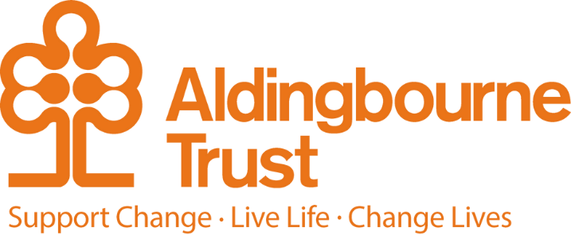

Job Description: Support Worker
Project: Create and Communicate
Work Location: Bognor Regis
Directly responsible to: Create and Communicate Lead
Overall responsible to: Support for Living Day Operations Manager

General purpose:
This role requires someone with a positive, flexible, and creative attitude to support adults with learning disabilities and autism at our Create & Communicate Project in Bognor Regis, a community outreach section of the Aldingbourne Trust.
You will be responsible for assisting the Project lead to support people to participate in activities at Creative Spaces, undertaking work-based creative craft and construction/making projects, learning cooking skills, making social connections and participating in the local community.
You support people to engage with tasks and activities; developing people’s abilities and confidence in order to positively impact their daily life, ambitions, well-being and self-esteem. You will support communication, expression, social engagement, and experimentation that leads to new ideas, new achievements and new goals, thereby promoting development, independence and documenting progression.

Key Terms and Conditions:
- Hours: 11 hours per week – 9.30-3.30 Thursday and Friday
- Pension: The Aldingbourne Trust offers a contributory pension scheme to qualifying staff.
- Annual leave:33 days in each year, which includes bank holidays. 1 extra day per annum after 5 years of service, up to a maximum of 5 extra days after 10 years, pro rota for part-time staff.
- Sick leave: After the first month's service, 2 weeks at full pay in a rolling 12 months per year
- Emergency family care/carer’s leave: Up to 6 days per annum pro rata for part-time staff.

Duties and Responsibilities:
- Support the Create & Communicate project and facilitate craft, cooking and community sessions, supporting people to achieve tasks and develop life and social skills.
- Cover for the Lead Support worker when required and liaise with the Creative Space’s Team and Peoples Home Support as required.
- Provide ‘Great Support’ that puts the person first, supporting a varied and exciting programme of creative activities for adults with learning disabilities in an accessible and relaxed, yet stimulating environment, which encourages people to have positive social interaction, try new experiences and acquire new skills.

- Support people individually and in groups to provide opportunities, support and teaching to aspire to their full potential by engaging in drama skills, cookery activities, art and craft and their local community.
- Promote peoples’ rights, independence, social inclusion and facilitate choice.
- Work with other Trust and Community projects to generate ideas, build positive relationships, promote partnership working and the achievements of the people we support as required.
- Contribute to a positive team dynamic.
- Take responsibility for your personal health and safety and that of the people we support by implementing health and safety procedures and safe methods of working, including pro-actively reporting issues and potential hazards.
- Accurate and timely record keeping and administration.
- Assist the Lead to ensure support plans are comprehensive and up to date and provide ongoing documentation on individuals’ progress in line with these plans.
- Provide support in accordance with agreed plans and Trust policies and values.
- Recognise and implement safeguarding procedures to protect the people we support, which includes whistleblowing when appropriate.
- Support people to become as independent as possible. Demonstrating genuine respect for people with learning disabilities, keeping people, places and items safe, using risks as opportunities.
- Treat everyone with dignity and respect, ensuring their confidentiality is maintained.
- Embrace person centered approaches and achieve positive outcomes.
- Provide personal care if it is required.
- Identify and manage any conflict, deal with any concerns/complaints in a professional and timely manner.
- Ensure self-awareness - mutually supportive relationships, asking for advice and/or support when needed.
- Be a role model, you are expected to act with integrity within and outside the Trust.
- Ensure you maintain a programme of continuing professional development.
- To perform any other duties that are commensurate with the post and may be specified from time to time by the organisation.
- This post is a regulated activity. As the post holder, you will be expected to undertake a DBS check, at enhanced level and against the Adult Barring List. Regulated activity (adults) as defined by the Safeguarding Vulnerable Adults Groups Act 2006.

Person Specification

Essential:
- Ability to support, motivate and engage people in creative tasks
- Good planning and organisational skills
- IT/Administration/Reporting experience
- Effective communication and listening skills
- Ability to stimulate and engage in conversation
- Problem solving skills and personal adaptability
- Proactive, self-motivated and desire for self-development
- Reliable team worker

Desirable:
- Experience in working with people with neurodiverse conditions
- Skills and experience that relate to particularly craft and cookery
- Makaton, British Sign Language or communication passports/exchange systems
- Experience of delivering personal care
- Knowledge of local area and networking skills
- Relevant experience of project planning, coordination or management
- Digital photography skills to photograph artwork with people

Employee Benefits:

- Life Assurance: 2 x your annual salary
- Employee Assistance Programme
- Bicycle voucher scheme
- Eye care vouchers
- Discounted gym membership
- 10%staff discount at Seasons Nursery (based at Aldingbourne Country Centre)
- 10% discount in ACC shop, ACC café, Horticulture, Make and Make Café.
- Free admission to ACC (Family of 4 with member of staff present)
- Flu Vaccinations
- £200 refer a friend scheme (payable when the new person starts)
- Funded Blue Light Card (1,000’s of discounts)

Document control

Prepared for | Internal review
Status | Manager Reviewed
Version | V2
Date | 15 July 2026

