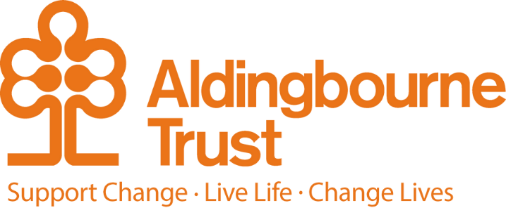

Job Profile: Housing Team Leader

Project: Housing

Work Location: No 73, Aldwick Bognor Regis

Directly responsible to: Head of Support

Overall responsible to: Managing Director

This is a unique role in the Trust combining experience of supporting a Housing team which includes maintenance, liaising with landlords and ensuring our services are compliant with all relevant legislation with experience of managing properties whose tenants are adults with a lived experience of learning disability, autism and mental health

We support 135 people with housing related support or tenancy support. We also work with our supported living teams and other community bases organising maintenance, repairs and carrying out regular property checks. Our team also is the initial point of referral for housing vacancies across the organisation.

Our purpose and vision?

To ensure that people have settled, safe well-maintained homes and have a happy place to live.

Therefore we:

Actively collaborate with tenants, their families, social workers, landlords, local council, team managers, and the wider Trust to ensure our purpose and vision is true.

What you will get from working with us:

* An appreciation of working in a team that believes in its purpose and is supported by the wider Trust.
* An opportunity to deepen knowledge and learning in areas that are of interest and support the purpose of the team.
* A climate where decision making is based on open conversations and appreciation of all the information with everyone’s views being actively sought.
* Getting to know the people we support, their families and investing in their wellbeing and futures.

What you should know, bring to the role:

* Experience of leadership and the ability to inspire us and those you interact with.
* Ability to work collaboratively, share decision making and encourage your own and others learning opportunities.
* Manage your time, balancing the role and its responsive nature with your own wellbeing.
* Experience in managing a wide portfolio of properties, liaising with landlords and managing maintenance, repairs and redecs.
* Understanding of all legal and statutory compliance requirements
* Confidence in speaking, communicating in writing and collaborating with a network of people within the Trust and externally, representing the organisation and its values.
* Competent knowledge of Housing Standards set out by the Homes and Community Agency and ability to translate this into the best possible tenancy management practices.
* Housing Management Qualification would be welcomed or a commitment to undertake one to embed knowledge.
* Ability to work across IT platforms such as Teams, Outlook, Office, Word, Excel and databases.
* Working knowledge of the Care Act and the Mental Health Act.
* Curiosity.
* Ability to ensure that the information needed by colleagues and the wider Trust, external agencies is completed in a timely and accurate way.

This post will require the postholder to work alongside vulnerable adults and therefore to have the required level of DBS Check.

**Key Terms and Conditions:**

* Salary 32,350 pro rata
* Hours of work 30 hours (but job share is optional)
* Pension: The Aldingbourne Trust offers a contributory pension scheme to qualifying staff.
* Annual leave: 25 days in each year, pro rata for part time staff. 1 extra day per annum after 5 years of service, up to a maximum of 5 extra days after 10 years.
* Sick leave: After the first month’s service, 2 weeks at full pay in a rolling 12-month period (pro rata if Part Time)
* Emergency family care/ career’s leave: Up to 6 days per annum (pro rata if Part Time)

**Employee Benefits:**

* Life Assurance: 2 x your annual salary
* Employee Assistance Programme
* Bicycle voucher scheme
* Eye care vouchers
* Discounted gym membership
* 10% in ACC shop, ACC café, Horticulture, Make and Make Café.
* Flu Vaccinations
* £200 refer a friend scheme (payable when the new person starts)