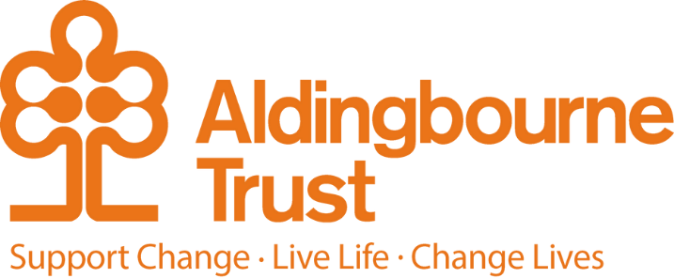

Job Description – Creative Crafts Support Worker

Project: MAKE@Aldingbourne Enterprises

Work Location: MAKE – Fratton, Portsmouth

Directly responsible to: Manager, MAKE

Overall responsible to: Managing Director, Aldingbourne Trust

**General Purpose:**

Are you creative? Are you resourceful? Do you want to have fun and make a difference whilst at work? If you answered yes, we have the perfect job for you.

MAKE is a unique creative hub in Fratton, where you can expect the unexpected and the sky really is the limit. You will creatively support people who have a learning disability and/or autism to engage in a variety of creative arts, crafts, recycling projects and produce saleable products to sell in the shop at Make and at community events, festivals, markets, and fairs.

You will be a keen Pinterest researcher and thrive on thinking out of the box to create innovative, unusual, quirky, unique products. Providing a stimulating, accessible and relaxed environment that encourages the people we support to try new experiences and acquire new skills.

You will support people to produce saleable products and have a clear scheme of work which will cover all stages of learning from design, creating the product, brand, promotion, price, packaging, merchandise, and sales. You will promote your finished products in our shop and on our social media pages and other online selling platforms.

The post holder will play an active supportive role within a small energetic, hardworking team ensuring agreed objectives are met in an effective manner whilst upholding the values of the Trust.

**Key Terms and Conditions:**

* Hours of work – 30 hours per week across 5 days, predominantly Monday – Friday. 9:30 – 16:00 (30 min break) We would expect you to be a team player and work one Saturday each month. There are occasions when we would ask you to work an occasional Sunday or evening for special events with prior notice.

**Duties and Responsibilities:**

* Support people to develop their skills and learning through meaningful, well-planned activities by motivating, developing, and supporting people to be creative.
* Support people to create a variety of creative arts, crafts, recycling projects and produce saleable products to sell in the Trust’s shops, online, on our social media pages and at community events, markets, and fairs.
* Actively research creative, new ideas on Pinterest and think outside the box to create innovative, unusual, quirky, unique products.
* Keep updated with local trends and participate in community initiatives when appropriate.
* Creatively engage in community activities, events, exhibitions and alike; raise awareness of the Trust, and creatively collaborate to become a community of place and people.
* Plan and organize a scheme of work which covers all stages of learning from design, creating the product, brand, promotion, price, packaging, merchandise, and sales whilst supporting people to learn through each stage.
* Support, review, and evidence individual development plans and contribute to their annual progress reviews.
* Provide a stimulating, accessible and relaxed environment that encourages the people we support to try new experiences and acquire new skills.
* Encourage independent thinking, provide new opportunities for people so they grow in self-confidence and try new things.
* Be a role model for the people we support and an ambassador for the Trust, ensuring high standards of support and customer service are delivered when working.
* Consider the use of a variety of creative mediums and technology when supporting and creating new products.
* Plan, budget, and purchase all creative materials at the least cost possible ensuring maximum profit; explore free resources, recycled products, and donations. Liaising with your line manager to ensure budget forecast is met.
* Support your colleagues and be a team player by participating in community networking events such as exhibitions, community projects, art trails and alike.
* Ensure you treat everyone equally and with dignity. Observing Health & Safety Regulations and Safety procedures under the Health & Safety at Work Act and adhere to all Trust policies.

**Person Specification:**

**Essential:**

* Experience of working in a creative environment or evidence of how creative you are and what skills you can offer.
* Ability to research ideas on online platforms such as Pinterest to create innovative saleable products from recycled materials or at a low cost.
* Ability to take initiative and work alone and in a team.
* Confidence to support a diverse group of people who have a learning disability and / or autism.
* Strong communication and listening skills.
* Good planning and organizing skills.
* Good literacy, numeracy, and IT skills.
* Good awareness of social media and online selling platforms such as Etsy
* Team player within a small energetic team.
* Flexible and willing to work one Saturday in a month and occasional weekends / evenings for events.
* Ability to create a fun working environment, whilst ensuring day to day tasks are achieved.

**Desirable:**

* Previous experience working with people with learning disabilities / autism.
* Understanding and ability to use TEAMS, Adobe suite and other creative online packages.
* A creative skill / craft you already could teach the people we support and create a saleable product from.
* A qualification in the arts spectrum
* Have a Full UK Driving Licence and access to a vehicle.

**Additional:**

* You will be required to complete any other reasonable duties commensurate with the post. Such as prompt the people we support to wear protective clothing or responding to someone who maybe sick or needs help with medical assistance.
* You may be asked to drive the people we support or colleagues to training, activities and events in the community. Business insurance is required for this element of the role.
* This post is a regulated activity. As the post holder, you will be expected to undertake a DBS check, at enhanced level and against the Adult Barring List. Regulated activity (adults) as defined by the Safeguarding Vulnerable Adults Groups Act 2006 from 10th September 2012, for the purposes of this post are: providing personal care, assistance with general household matters, conveying people.  We have assessed this post and are satisfied that it is reasonable and likely that the post holder will be required to engage in any or all of these regulated activities.

**August 2025**