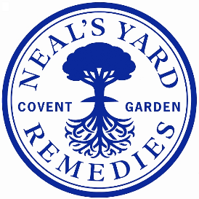

JOB DESCRIPTION
Job Title: Product Manager
Reporting to: Senior Product Manager
Direct reports: Assistant Product Manager
Why this role matters
Every role at Neal’s Yard Remedies plays a vital part in bringing our purpose to life and in driving our next chapter of growth and transformation. Guided by our values and our commitment to putting customers first, you’ll contribute to a business that’s good for people and the planet and deliver products and experiences that truly make a difference.
Sitting within the Product Development team, you’ll be responsible for supporting the NPD plan for the team! There has never been such an exciting time to join, you’ll be responsible for delivering natures finest, efficacious, products to market.
Where you’ll play to win:
• Responsible for the end-to-end process of new product development. From conceptualisation and translation into written brief, working with insights to gain robust consumer validation. Landing finished goods on time, in full and within cost, performing in line with commercial forecasts.
• Translation of macro trends and consumer insights into product. Using insight to drive micro product decisions including packaging, formulation, fragrance, claims and design attributes. Always putting the customer at the forefront of decisions to execute consumer relevant quality.
• Work hand in hand with the brand team to deliver the strategy into a product pipeline and execute best in class engagement.
• Responsible for working with external & internal partners; including research, manufacturing and design agency partners to confidently brief and critique to deliver against business objectives.
• Deliver effective matrix working with multiple cross-functional teams and effectively manage stakeholders and peers to ensure activities are delivered on time with approval and buy-in at key decision points.

What does success look like in this role:
• Proven product experience on end-to-end NPD projects, delivering products in market for a product development team.
• Must have experience of working to identify and understand consumer needs & trends into product propositions for the business.
• Passion for product development and bettering the lives of consumers.
• Proactive, independent and self-starting individual, with a passion for beauty and good understanding of the latest product trends and launches.
• Can demonstrate experience of managing multiple product development projects simultaneously, working cross functionally and strong ability to sell in a compelling & engaging product proposition to key stakeholders.
Capabilities: What makes you great for this role
· Collaborate Cross-Functionally
· Strong stakeholder engagement skills, able to communicate and engage with diverse cross functional teams around a shared vision
· Champion a solution focused mindset, encouraging experimentation and continuous improvement.
· Passion for beauty that drives joy for the consumer.

