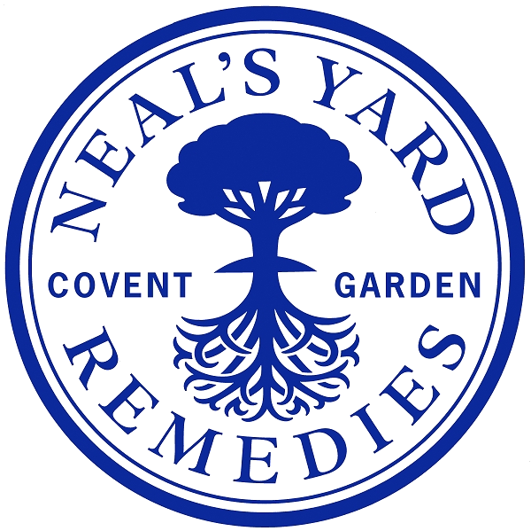

Job Title: | Product Designer
Department: | NPD
Location: | Peacemarsh or London
Reports to: | Head of Product Management
Direct reports:
Purpose: | As a key member of our product development team, the Product Designer will fuse creativity, technical expertise, and a passion for beauty to create standout packaging that elevates our brand and embodies our ethos of sustainability, innovation, and ethical responsibility. This role is perfect for someone who brings international perspective, market curiosity, and a finger on the pulse of modern beauty trends.  You'll partner with cross-functional teams to engineer and deliver best-in-class packaging solutions—balancing aesthetic excellence with functional design, sustainability, and commercial viability.
Role Responsibilities: | Lead end-to-end development of innovative packaging from concept through to launch, ensuring alignment with brand values, sustainability goals, and global beauty market expectations.  Translate creative briefs into technically viable packaging designs that meet regulatory, performance, and aesthetic criteria.  Engineer solutions using modern materials and sustainable processes, focusing on recyclability, reusability, and waste reduction.  Own and oversee testing protocols for packaging components, ensuring performance and quality under real-world conditions.  Attend first production runs, print approvals, and troubleshoot technical issues with suppliers and manufacturers.  Collaborate with Operational teams to ensure packaging meets ethical sourcing and production standards.  Conduct feasibility assessments, managing costs and ensuring commercial awareness throughout all projects.  Champion innovation and emerging trends, scouting materials and design inspiration from the global beauty landscape.  Contribute to artwork development, ensuring technical accuracy and brand consistency.  Create and maintain detailed packaging specifications and documentation.  Support the business with technical input during supplier meetings, audits, and project scoping.  Mentor junior team members, sharing knowledge and fostering a culture of excellence and curiosity.  Ensure packaging projects adhere to timelines, budgets, and critical path milestones.  Monitor and report packaging waste and compliance in line with regulations such as NLF and Extended Producer Responsibility.  Stay at the forefront of global sustainability innovation, attending relevant conferences and trend events.
Person  Specification: | 3–5+ years experience in packaging design and/or product engineering, ideally in the beauty, cosmetics, or personal care industry.  Deep knowledge of packaging materials, decoration techniques, sustainability innovations, and production processes.  International or global market experience highly desirable.  A natural trendspotter with a passion for beauty products, packaging innovation, and the evolving consumer landscape.  Proven ability to balance design creativity with technical precision and commercial constraints.  Strong communicator and collaborator with cross-functional teams.  Familiar with compliance and sustainability standards in packaging, including EPR and cosmetic regulations.  Comfortable working in a fast-paced, creative, and values-driven environment.  Proficient in tools like Adobe Illustrator, SolidWorks (or other CAD), Microsoft Office, and PLM systems.  Passionate about ethical business, natural and organic ingredients, and delivering meaningful impact through design.  A curious mindset and willingness to explore, test, and challenge norms.  A passion for beauty, innovation, and the global beauty culture.  A collaborative spirit with strong ownership and problem-solving skills.  A desire to make a measurable contribution to a more sustainable future.

Date Compiled:

Compiled by:

Job Descriptions may not cover all duties and responsibilities as these may be subject to change at any time and without notice. All job holders will be expected to carry out additional duties as requested to suit the needs of the business.

