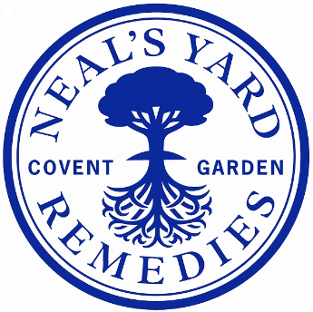

|  |  |
| --- | --- |
| **Job Title:** | Regulatory Officer |
| **Department:** | NPD |
| **Location:** | London/Peacemarsh (hybrid) |
| **Reports to:** | Product Development Manager, Fran Johnson |
| **Direct reports:** | N/A |
| **Purpose:** | The Regulatory Officer will provide pragmatic and commercial regulatory advice to ensure business compliance with regulatory obligations on Health & Beauty products both in the UK and internationally. |
| **Role Responsibilities:** | * Work closely with the product, design and technical teams, as well as the copywriters to ensure all of Neal’s Yard Remedies’ artworks, formulations, product labels, promotional literature and training are compliant for required market including warnings and INCI. * Advise Formulators and Brand Managers on pack and marketing claims and with recommendations for claims substantiation and testing and provide business with associated risk analysis. * Keep up to date and advise on regulatory requirements for cosmetics (and other categories as relevant) in the UK and existing export markets, in particular, the USA and EU and share information as required. * Investigate the requirements and share updates for any potential new markets. * Provide pragmatic and commercial regulatory advice. * Review relevant company practices and provide advice on changes to systems and procedures. * Implement processes to ensure best practise within the relevant regulatory area. * Keep up to date with international legislation, guidelines and international franchise and wholesale practices in all relevant territories. * Analyse complicated information, including clinical and consumer trial data and contribute to cross-disciplinary projects within the scientific and regulatory network. * Drive regulatory excellence and support the business with technical queries providing technical information to retailers/distributors when required * Maintain ongoing product compliance and ensure all products are compliant with latest regulatory requirements, informing and working with teams to action changes in good time. * Advise on acceptable claims for products, social media and promotional literature in different formats. * Provide strategic advice to senior management throughout the development of new products. * Review and approve storage, labelling and packaging requirements. * Proactively advise and seek out ideas for innovation and product updates. * Advise on certifications including COSMOS Natural and Organic and maintain relationships with certification bodies.   **HEALTH & SAFETY**   * Engage in our positive health and safety culture. * Notify the company of any potentials risk to your, or your colleagues, health, safety and wellbeing whilst at work. * Cooperate with the company by following processes and training provided on health and safety. |
| **Person**  **Specification:** | * Naturally embodies the values contained in the ‘Essence of Neal’s Yard Remedies.’ * Motivated and organised with excellent communication skills and a passion for cosmetics * Excellent analytical skills, commercially driven with an eye for detail * Experienced in providing advice for regulatory and compliance issues for cosmetics internationally, with particular experience of the USA, UK and EU regulatory environment. * Product knowledge and techniques used for claim substantiation essential. * An interest in or knowledge of organic certification and associated product claims. * An understanding of cosmetics regulation, ingredients, chemicals regulation, CLP, packaging regulation as applicable in UK and EU and internationally. |

**Date Compiled**: 19th June 2025

**Compiled by**: Fran Johnson

Job Descriptions may not cover all duties and responsibilities as these may be subject to change at any time and without notice. All job holders will be expected to carry out additional duties as requested to suit the needs of the business.