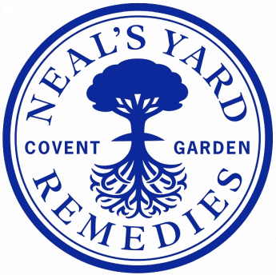

|  |  |
| --- | --- |
| **Job Title:** | **Quality Laboratory Technician** |
| **Department:** | Quality |
| **Location:** | NYR Peacemarsh |
| **Reports to:** | Quality Laboratory Team Leader |
| **Direct reports:** | None |
| **Purpose:** | To assist with the running of the QC laboratories |
| **Role Responsibilities:** | **General:**  Daily balance checks; temperature checks; water checks and humidity cupboard. Recording all data on relevant paperwork. Report all issues to a microbiologist  Check QC consumable levels weekly. Update microbiologists for ordering with external suppliers or the warehouse team for lab consumables  **Microbiology:**  Assist with organising, placing and collecting environmental samples from production  Assist with booking in samples  Assist with testing swabs, water samples and product samples  Assist with media preparation  Assist with maintaining a hygienic and compliant working environment  Assist with stock control and stock rotation  Assist with autoclaving media and control of waste  **QC laboratory:**  Provide early-morning cover for make & fill bulk testing and release when required  Provide absence cover when requested, including testing and releasing raw materials and bulk products  Assist with maintaining the laboratory in a clean and compliant condition  Assist with sampling raw materials and basic laboratory testing as required  Booking in Samples, Retaining samples and scanning paperwork  **Admin:**  Assist with stock control and stock rotation  Assist with filing and archiving  **Health and Safety:**  To comply with NYR’s H&S procedures. |
| **Person**  **Specification:** | **Essential:**   * Good work ethic * Willingness to learn * Able to work in a clean and tidy manner * Good communication skills and written/spoken English * Understanding of and empathy with NYR’s values * Valid UK work permit allowing full time work   **Preferable:**   * Experience with Microsoft office |

**NYR Quality Department structure Sep-24**

**Date reviewed**: August 2024

**Reviewed by**: Sarah Eades, Head of Quality.

Job Descriptions may not cover all duties and responsibilities as these may be subject to change at any time and without notice. All job holders will be expected to carry out additional duties as requested to suit the needs of the business.