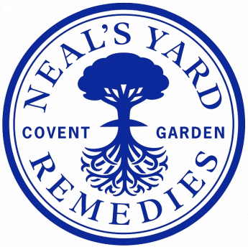

|  |  |
| --- | --- |
| **Job Title:** | **Quality Inspector** |
| **Department:** | Quality |
| **Location:** | NYR Peacemarsh |
| **Reports to:** | Quality Inspections Team Leader |
| **Direct reports:** | None |
| **Purpose:** | To protect the NYR brand and prevent delays in production by checking incoming goods and components to ensure compliance with quality specifications, and for referring issues to the appropriate people for decision. |
| **Role Responsibilities:** | **Quality Inspections:**  Inspection of incoming components and finished goods to ensure compliance with quality specifications.  Inspect products for Japan as required.  Inspect other componentry as required.  Escalating issues as appropriate.  **Administration:**  Assisting with maintenance of QC records including spreadsheets and databases.  Maintain componentry standards  Retaining samples and scanning paperwork  Assist with stock control and stock rotation.  Assist with filing and archiving.  **Compliance:**  Ensure compliance with internal quality system requirements.  Ensure compliance with all externally audited systems including ISO 22716, MHRA, FDA, GMP and HACCP.  Assist Head of Quality with audits from external bodies and feedback reports relating to those audits.  Assist Head of Quality with corrective and preventative action plans.  **Continuous Improvement and Self Development:**  To assist in ensuring that continuous improvement is driven throughout the team and the organisation.  To continually develop their own and their teams skills/performance.  **Health and Safety:**  To comply with NYR’s H&S procedures.  To report H&S risks and hazards to the Head of Quality/H&S Representative. |
| **Person**  **Specification:** | **Essential:**   * Able to demonstrate excellent organisational and analytical skills * Excellent communication skills and written/spoken English * Understanding of and empathy with NYR’s values * Confidence to work under own initiative, yet take direction well * Able to plan and manage own time effectively * Valid UK work permit allowing full time work   **Preferable:**   * Experience with NetSuite * Experience within cosmetic, pharma or food/drink FMCG industry in a quality role |

**NYR Quality Department structure**

**Date reviewed**: 05/06/2025

**Reviewed by**: Sarah Eades

Job Descriptions may not cover all duties and responsibilities as these may be subject to change at any time and without notice. All job holders will be expected to carry out additional duties as requested to suit the needs of the business.