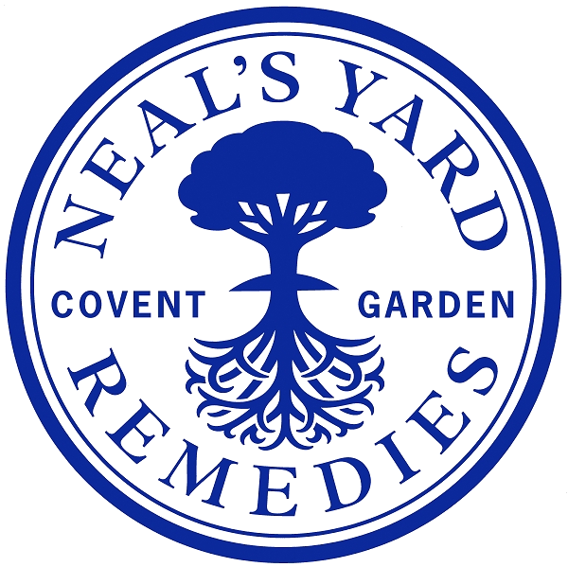

Job Title: | PR Executive
Department: | Marketing
Location: | Hybrid role, 2 days minimum a week in Covent Garden, London with occasional travel to our Eco-factory in Dorset and PR events.
Reports to: | Brand Communications Manager
Direct reports: | N/A
Purpose: | As PR Executive, you will play a key role in amplifying our brand voice and presence within the beauty and wellbeing space. You will support and deliver PR strategies that build strong media relationships, engage influencers and KOLs, and create impactful storytelling across campaigns and events. Bringing energy, professionalism, and a positive attitude, you’ll help drive our brand’s growth and reputation while championing our values.
Role Responsibilities: | - Support the planning and execution of integrated PR campaigns across media, events, influencer partnerships, and social platforms.  - A key contact for our PR agency, ensuring timely communication and effective execution of activation with the teams.  - Draft and distribute compelling press releases, product announcements, and campaign communications in collaboration with marketing, copywriting, and design teams.  - The guardian of our press asset bank, managing and organising press assets, including imagery, quotes, campaign materials, and awards to ensure the PR agency is equipped with the latest information to seed to press.  - Work closely with the Brand Communications Manager to fulfil any admin tasks related to brand exposure activations including but not limited to events, sampling opportunities, press outreach, and partnership opportunities.  - Build and maintain positive relationships with journalists, influencers, and key media contacts to secure coverage and brand visibility.  - Monitor media and social coverage daily to identify trends and opportunities for proactive engagement.  - Coordinate product seeding and gifting initiatives to influencers and media, collating product and packaging beautifully for send outs, ensuring timely and effective delivery.  - Management of product and packaging ordering for PR agency stock cupboards as well as in-house PR cupboards, keeping these managed and well organised.  - When required, packaging of goodie bags for in-house and partnership events.  - Manage the press office inbox, prioritising and responding to media requests promptly to maximise opportunities.  - Assist with organising and supporting product shoots, events, and experiential activities, ensuring seamless execution.  - Compile and present post-campaign reports measuring media impact, reach, and effectiveness.  - Stay updated on industry news, competitor activity, and emerging platforms to keep strategies fresh and relevant.  - Contribute to cross-functional projects and collaborations aligned with the brand’s strategic ambitions and values.
Person  Specification: | - Proven experience in PR, communications, or influencer marketing - preferably within beauty, wellness, or lifestyle sectors.  - Solid understanding of media landscapes, social media channels, and influencer ecosystems.  - Confident, articulate communicator with excellent written and verbal skills.  - Energetic, proactive, and solution-oriented with a positive, can-do attitude.  - Strong interpersonal skills and the ability to build and nurture professional relationships.  - Exceptional organisational skills and impeccable attention to detail; capable of managing multiple priorities under deadlines.  - Proficiency in Microsoft Office suite; familiarity with social media and media monitoring tools a plus.  - Professional and polished presence with the ability to represent the brand externally and internally.  - Collaborative team player who thrives in a dynamic, creative environment.

Date Compiled: June 2025

Compiled by:

Job Descriptions may not cover all duties and responsibilities as these may be subject to change at any time and without notice. All job holders will be expected to carry out additional duties as requested to suit the needs of the business.

