JOB DESCRIPTION

Job Title: Multiple needs housing support workers

Reports to: Health and Wellbeing Team

Place of Work: TBA

Hours: 37 hours per week – flexibly across 7 days rota –

Job Purpose:

Stonepillow provide services for people who are experiencing homelessness and many leading complex lifestyles due to their addictions, or physical and mental health support requirements. Stonepillow, in partnership with West Sussex County Council Public Health, have two exciting new positions to support and facilitate to provide intensive support to enable these clients to access the most appropriate accommodation to relieve their homelessness. They will also enable effective packages of support/care to be created to address the additional issues created by their addictions, in particular alcohol, and associated mental ill health.

Summary of the Roles

There will be two posts:
- One post will focus on supporting people who are affected, or at high risk of, cognitive impairment due to their chronic alcohol dependencies. This cognitive impairment may be impacting on their ability to gain access or to sustain engagement with a clinical and social pathway to support their additional needs. The role will focus on sourcing their best and most appropriate housing options which best enable them to live life to their full potential. In addition, with a wraparound support/care provided, the post will provide a holistic package. This worker will also become part of a programme being developed in West Sussex for the Alcohol Related Brain Damage (ARBD) pathway.

- The second post will work alongside the A&E department and hospitals to help develop an improved pathway back into housing for those patients who have no fixed address and are at risk of rough sleeping on discharge from hospital or A&E, The focus is on those who have a multiple and complex needs which include addictions and who are frequent attenders at urgent care. In particular, the post will support those with a primary support need around Alcohol dependencies, ensuring that their housing choices are available. It will focus also on providing support to access and sustain accommodation which best fits their needs with the aim of reducing repeat attendances at A&E.

Stonepillow support people using strengths based, trauma informed, collaborative and solution focused approaches. The Specialist Housing Support Workers will have a focused case load with the aim to provide stable accommodation. It builds on the housing first model which is already in place within Stonepillow, to find suitable and appropriate long-term housing solutions. ‘Specialist Housing Support’ will ensure a flexibility in approach and a positive and empowering support that will be trauma-informed with the goal to ensuring choice and control to the client. It is recognised we need to ensure clients have choice and control back into their lives though positive professional relationship building.

This role will be part of the Health and Wellbeing team. There will be close working with other outreach and residential services teams in Chichester and Arun. This is a highly specialist support worker role that will require case management supervision of all 15-20 clients who have high level multiple needs and risks associated with their lifestyles.

Key Results Areas/Success Measures

KR 1: | Deliver trauma-informed care approach and strength-based support based on the seven key principles of Housing First and Stonepillow support model with multiple complex who need secure housing.
Success Measure | Clients are engaged and report satisfaction with support and sustain their tenancy or licence agreement and are receive an effective support/social care pathway. Client records are maintained, outcome stars completed and risk and safety management for each individual up to date and effectively managed. Clear clinical or treatment in place.
KR 2: | Incorporate strengths based, trauma informed, collaborative and solution focused techniques into the relationships that you develop with clients and through into your support delivery.
Success Measure | Clients achieve the outcomes that they want to achieve. Key stakeholders Hospitals, adult Social Care, Housing Chichester, and Arun District councils report high satisfaction with Stonepillow’s delivery.
KR 3: | To coordinate and work as part of a multi-disciplinary team that supports clients to identify and meet their personal, social, health and employability needs.
Success Measure | Lead in coordinating and involving teams of relevant professionals tailored to each client’s needs and interests. Including linking in with RSI teams, registered and private sector Housing providers, Clinical Services, Treatment services and other Voluntary and Community based services.
KR 4: | Support clients to undertake practices that reduce harm and promote recovery for addictions and mental wellbeing. Using the Warwick Edinburgh model to capture their wellbeing improvements
Success Measure | Clients report increased wellbeing and are showing positive outcomes in their lives in line with their own goals. Using a harm reduction model and TIP, the role will ensure that clients are supported within a framework of PIE, TIP, and recovery models.
KR 5: | Provide holistic, wrap around support to build client independence and resilience. To be assertive in strengths-based support to motivate and have unconditional positive regard to clients –
Success Measure | Clients maintain their tenancy and demonstrate increased independence and building of their identity away from rough sleeping and towards moving them onwards to permanent housing.

Other Tasks/Success Measures

Task 1: | Fully engage with providing data, case studies and achievements throughout the project.
Success Measure | KPI achieved for service, personal development and assessment. Active involvement in monthly data capture to WSCC.
Task 2: | Use different techniques to enable each client to influence service delivery -TIC/PIE
Success Measure | Service delivery is adapted and tailored to each client, based on their feedback and preferences. Individualised support plans and goal settings for each client. Full choice and involvement in all aspects of their support.
Task 3: | Deliver life skills support so that clients develop the necessary skills in key areas of their lives
Success Measure | Including group work and individual coaching. Including community partnerships to enable improved results for clients. Building a positive and supportive community within the service
Task 4: | Tenure and income streams are maintained, and the client engages well with the local community
Success Measure | To ensure maximisation of benefits and Housing Benefits is maintained. To work with clients on budgeting and tenancy awareness. Ensure personal service charges are paid and within KPI targets.
Task 5: | To feed into the relevant groups across West Sussex which support learning and development of a system change for clients with Multiple and complex issues within their lives.
Success measures | This will mean attending meetings such as the ARBD group, contributing the development of a West Sussex ARBD pathway.  improved access to urgent care for clients who ordinarily maybe excluded or overwhelmed by health care services presently available. To improve access to primary care services working with GP’s community nurses and community mental health services to address health inequalities and improve outcomes.
 | To undertake other duties commensurate with the post, as delegated by your manager.

Communications and working relationships.
- To be a good team player and work constructively with colleagues and managers in all aspects of the post holder’s work.

- Contribute positively to meetings such as supervision, appraisal, team meetings and training events.

Health and Safety
- To ensure the health, safety and security of staff, students, clients, volunteers and members of the public on the premises in all locations in line with Stonepillow’s procedures.
- We have clear risk management and safety, protocols and procedures. These support staff and client’s when working away from whilst on and off Stonepillow fixed sites.

Confidentiality and GDPR
Confidentiality and information management about our clients is dealt with upmost care and consideration. We therefore have stringent Confidentiality, GDPR and information sharing policies, procedures and protocol.
- This policy covers all Stonepillow employees and volunteers, all of whom will be required to sign a confidentiality agreement.

- Any staff breaching this agreement will be liable to disciplinary action under the Disciplinary Procedure.

General
- To undertake such other reasonable duties as may be required in the interest of Stonepillow.

- To work within Stonepillows vision and ethos in all aspects of the work you do.

Stonepillow Values:
- Stonepillow values were developed by the organisation and are keenly observed by all. To ensure we provide a positive and psychologically informed environment and clients can receive services in the most effective, professional and compassionate manner.
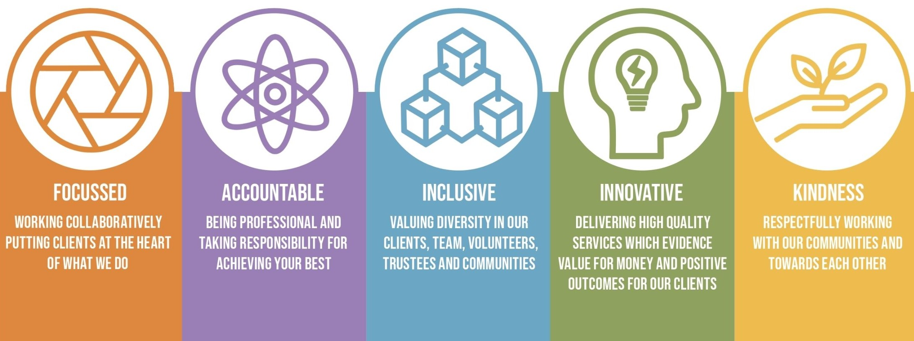

Appointment to this position is subject to satisfactory enhanced disclosure via the Enhanced Disclosure Barring Service.
You will need access to a car and a driving licence for this role.
Person Specification
This person specification lists the knowledge, skills and experience required.
E= Essential criteria D= Desirable criteria S= Shortlisting criteria I= Interview criteria
Experience
Experience of supporting multiple disadvantage | E /S/I
Experience of supporting people who are homeless or at risk of homelessness | D/S/I
Experience of facilitating meetings | E/S/I
Experience of working with partner agencies | D/I
Experience of delivering training | D/I
Knowledge
Good knowledge of multiple complex factors which contribute to the risk of homelessness including domestic abuse/violence, mental health, substance misuse and economic disadvantage | E/S/I
An understanding of trauma and gender informed working | E/S/I
Working knowledge of therapeutic interventions such as motivational interviewing | D / I
Skills
Excellent ability to communicate with a wide range of people to develop and form constructive relationships | E/I
Ability to understand, empathise and uphold Stonepillows aims and policies | E
Ability to advocate on behalf of clients to other professionals | E/I
Excellent crisis management skills, including the ability to cope in stressful situations, able apply de-escalating techniques | E/I
Commitment to personal development, ability to make good use of supervision, reflect on working practice and attend clinical supervision | E/I
Good computer literacy skills including case management database | E/I

