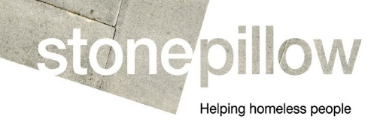

Person Specification
Dual Diagnosis Worker
1 x Part Time (22.5 hrs pw) in Bognor Regis

This person specification lists the skills, knowledge and experience required. You should provide evidence, in the form of an example, that you meet each criteria on your application form.

E = Essential criteria D = Desirable criteria

Criteria | E | D
Education
Good Standard of Education | E
Relevant professional qualification in housing social work, counselling or other related field |  | D
Experience
Experience of working with clients who present with challenging behaviours. | E
Good knowledge of alcohol, drugs and issues around addiction and relapse management | E
Good knowledge of mental health, personality disorders and dual diagnosis | E
Experience of identifying and securing person-centred residential treatment programmes. | E
Experience of providing housing options advice |  | D
Experience of working with people who are or are at risk of becoming street homeless.
Experience of securing sustainable accommodation for those threatened with homelessness |  | D
Good knowledge of local agencies providing services relevant to the client group. |  | D
Knowledge and Skills
Practical knowledge and understanding of the treatment pathways for individuals with mental health problems and dual diagnosis | E
A thorough understanding of homelessness and the links with mental health and substance misuse problems | E
Practical knowledge and understanding of the drivers of homelessness and rough sleeping | E
Demonstrable knowledge of the welfare benefits system, including Universal Credit | E
Knowledge of homelessness legislation and relevant codes of guidance |  | D
Commitment to and good understanding of equality and diversity | E
General
The ability to forge effective working relationships within a team | E
Commitment to personal growth and extending own professional competence and knowledge. | E
Good computer literacy skills and ability to make effective use of systems | E

