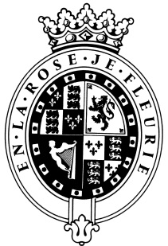

GOODWOOD

The Role

The Livestock & General Farm Worker will be part of the Home Farm team and report to the Farm Manager.

About us

Goodwood is a quintessentially English estate, set in 12,000 acres of rolling West Sussex countryside. Rooted in our heritage, we deliver extraordinary and engaging experiences in modern and authentic ways. But what really sets us apart is our people. It is their passion, enthusiasm and belief in the many things we do that makes Goodwood the unique place it is.

Passionate People

It takes a certain sort of person to flourish in such a fast-paced, multi-dimensional environment like Goodwood. We look for talented, self-motivated and enthusiastic individuals who will be able to share our passion for Goodwood to be ‘the home of exceptional experiences’.

Our Values

The Real Thing Derring-Do Obsession for Perfection Sheer Love of Life

Always inspired by Goodwood’s heritage | Daring to surprise and delight | Striving to do things even better | Sharing our infectious enthusiasm

Purpose of the role

To look after a 15 sow organic breeding to finishing outdoor pig-unit, to assist with tasks on the dairy/beef/sheep units and tractor driving

Key responsibilities

- To look after a 15 sow organic breeding to finishing outdoor pig-unit and maintaining a high level of animal husbandry in all tasks undertaken
- Provide the butchery with a consistent supply of finished pigs on a weekly basis, this will include selecting stock, identification of stock and transport to the local abattoir
- Ensure pig unit meets Soil Association and Red Tractor Assurance standards
- Other tasks could include feeding and bedding up cows and calves, mucking out, moving stock, fencing and tractor field work

Qualities you will possess

- Passion for what you do
- Proactive approach to getting things done
- Take responsibility for yourself
- Confident to make decisions and to stand by them
- Positive and friendly with a “can do attitude”
- Attention to detail
- Ability to prioritise and organise
- A sense of fun!

What do you need to be successful?

- Experience of working with outdoor pigs is essential
- Agricultural qualification preferable
- Proven experience with a range of machinery including tractors and telehandlers
- Ability to manage own time to ensure all tasks are completed
- Hard working, a team attitude is essential
- Full driving licence

