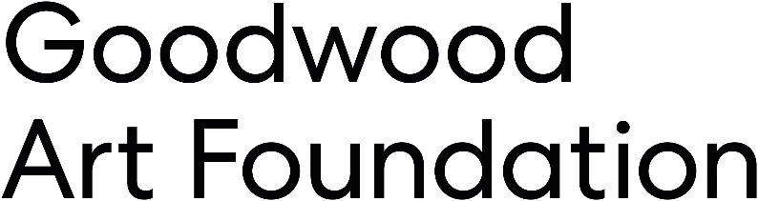

**Job Title:** Marketing Manager  
**Location:** Goodwood Art Foundation, Goodwood Estate  
**Reports to:** Head of Marketing and Communications

**About Goodwood Art Foundation**

Goodwood Art Foundation is a brand-new not-for-profit Community Interest Company located on the Goodwood Estate. Spearheaded by The Duke of Richmond, this world class contemporary art foundation has been formed to promote three pillars of Art, Environment and Education.

Our purpose is to benefit adults, young people, and children through providing access to important works of contemporary art set within a stunning natural environment that has been carefully designed to promote nature and encourage biodiversity. A comprehensive education programme is linked to both the artistic and environmental elements of the programme and will target those schools and pupils in most need of support. Working with leading figures in the curation of contemporary art, award winning landscape design and leading education programme, we have created something truly unique with a global focus.

**Job overview**

This role will suit a creative and driven individual with ideas, energy and enthusiasm, and experience of working in a small team.

We are particularly looking for an individual with strong digital marketing, communications and content production experience who can drive this activity for the Foundation, playing a critical role in promoting the artistic programme, education programme, Schwarzman Gardens, the catering offer and events programme.

They will take an audience- and data-led approach to their work, optimising marketing activity to maximise revenue through ticket sales and footfall to Goodwood Art Foundation. They will deliver creative, sector-leading communications and content that builds reach, establishes the Foundation’s reputation and raises awareness of its mission.

**Key responsibilities**

Digital Marketing

* Manage digital advertising campaigns, either as standalone campaigns or as part of multi-channel end-to-end campaigns. This role will develop and deliver Meta ad strategy, and brief and oversee Google campaigns through the media agency
* Working with designers, plan, brief and deliver compelling assets for ad campaigns
* Deliver monthly reports on digital performance
* With relevant colleagues, develop campaigns that support retention and acquisition of members as part of the membership strategy

Digital Communications and Content

* Responsible for ensuring a holistic approach to building our digital profile that will support reputation, reach and revenue targets
* Plan and oversee production of digital content including films, photography and animations, managing the annual shoot calendar
* Manage social media channels including planning, producing and delivering compelling organic content to drive engagement, reach and conversion
* Manage email communications, owning the newsletter calendar, copywriting emails, overseeing the customer flows and liaising with the Goodwood Campaigns team accordingly
* Lead on website management and updates including the editorial plan for the News section, ensuring the website is optimised and up to date, and liaising with the Goodwood Web team accordingly
* Manage a content calendar for the Visitor Screen to ensure key marketing initiatives are represented onsite
* Work with external partners to identify opportunities for cross-promotion across digital channels
* Work with relevant colleagues to ensure a seamless user journey for audiences through the website and ticketing process, liaising with the ticketing team as needed
* With the Head of Marketing and Communications, respond to crisis or operational communications requirements, planning and delivering digital activations

Marketing campaigns

* Deliver end-to-end multi-channel marketing campaigns for the Foundation’s projects, delivering digital and offline advertising, social media, website and print marketing elements
* Manage the production processes for a range of marketing activities including print programmes, press adverts, photography and signage
* Provide the day-to-day management of agency relationships as required, including media buyers, printers and other suppliers to deliver campaigns
* Maximise partnerships with tourism bodies, peer organisations, partners and artists to identify opportunities for cross-promotion

**Key requirements**

* Strong experience working in a similar marketing role with strong experience in digital
* Proven track record in delivering successful digital campaigns and engagement
* Experience planning, developing and delivering integrated campaigns that successfully meet and exceed targets
* Excellent command of the English language and strong copywriting skills
* Ability to be proactive and manage multiple deadlines and conflicting work priorities
* Strong and clear communicator, able to work within a team environment as well as independently
* A solid understanding of best practice in marketing and communications
* Exceptional organisational skills and great attention to detail
* Ability to analyse and interpret digital performance data and make recommendations accordingly
* Excellent interpersonal skills and the ability to build strong relationships with colleagues, stakeholders and external partners
* The ability to think creatively, with a curiosity for good stories and the confidence to bring ideas to the table
* An eye for design and experience of working closely and effectively with creative teams, from brief writing through to creative development and production
* Experience of working with digital marketing platforms, CMS, CRM and ticketing systems
* Preferably a passion and interest in arts, environment or education

**Benefits**

* Competitive salary of £40,000 pro rata
* A generous Benefits package
* Work within a dynamic and prestigious environment at the Goodwood Art Foundation