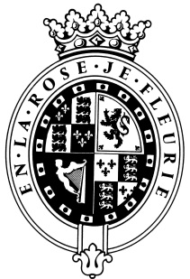

GOODWOOD

The Role
The Assistant Greenkeeper will be part of Golf Course Maintenance Team and report to the Head Greenkeeper.

About us

Goodwood is a quintessentially English estate, set in 12,000 acres of rolling West Sussex countryside. Rooted in our heritage, we deliver extraordinary and engaging experiences in modern and authentic ways. But what really sets us apart is our people. It is their passion, enthusiasm and belief in the many things we do that makes Goodwood the unique place it is.

Passionate People

It takes a certain sort of person to flourish in such a fast-paced, multi-dimensional environment like Goodwood. We look for talented, self-motivated and enthusiastic individuals who will be able to share our passion for Goodwood to be ‘the home of exceptional experiences’.

Our Values

The Real Thing Derring-Do Obsession for Perfection Sheer Love of Life

Always inspired by Goodwood’s heritage | Daring to surprise and delight | Striving to do things even better | Sharing our infectious enthusiasm

Purpose of the role

To carry out routine golf course maintenance tasks as directed by either the Head Green Keeper or Deputy, in accordance with the Golf Course Policy and Continual Development Training Scheme.
Key responsibilities

- To establish and maintain effective, respectful working relationships with managers and colleagues.
- Attend department meetings and/or operational meetings as required.
- To maintain Health and Safety working practices within the department.
- To ensure all work is carried out to the required standard as outlined and trained within the Company continual development training scheme.

Qualities you will possess

- Passion for what you do
- Positive and friendly with a “can do attitude”
- Attention to detail
- Ability to prioritise and organise
- Proactive
- Take responsibility for yourself

- Confident to make decisions and to stand by them
- Good negotiation and influencing skills
- Excellent communicator
- A sense of fun!

What do you need to be successful?

- Possess a NVQ Level 2 in Sports Turf Maintenance, or equivalent certification, such as the Certificate in Golf Greenkeeping or the Work Based Diploma in Sports Turf.
- Spraying Certificates (PA1, PA2, and PA6). These are crucial for the safe and legal application of pesticides and fertilizers.
- Can demonstrate a history of working to a high standard of excellence.

