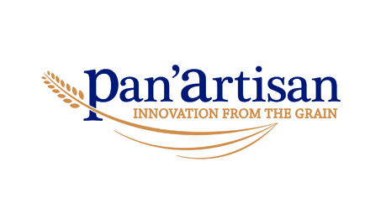
JOB DESCRIPTION
Position: PRODUCTION OPERATIVE
Report to: LINE SUPERVISOR
Hours of work: Shifts between 6am and 10pm from Monday to Friday
Shift between 6am and 12pm on Saturday if required.
Job purpose:
Working within a team producing bakery products performing various activities within the factory which includes handling food through the various stages from weighing to packing.
Duties:
- Weighing and mixing of ingredients in accordance with Process Manual
- Moving dough between production points including placing pieces into pans.
- Lifting and loading of full and empty pans into racks.
- Pushing of large racks (empty and loaded) between production points.
- Stacking boxes with weights of up to 20kg onto pallets, with consideration to H & S guidelines.
- To adhere to Good Manufacturing Practices at all times, which includes food safety, housekeeping and process adherence.
- To produce products to the required quality standards adhering to recipes and specifications and reporting any issues to the supervisor or manager as soon as they are evident.
- To comply with all Health and Safety requirements and reporting any Health & Safety issues, including unsafe behaviour in the workplace.
- To assist with keeping the production area clean during production with “clean as you go” policy
- To assist cleaning the production line and area of work at the end of the shift.
- To perform any other reasonable tasks requested by supervisors and managers.
Key Qualities and skills:
- Attention to detail and pride.
- Ability to work under own initiative and meet the required standards.
- Understanding of food safety.
- English is the language of operation on site.
- Physically able to complete the required tasks effectively.

