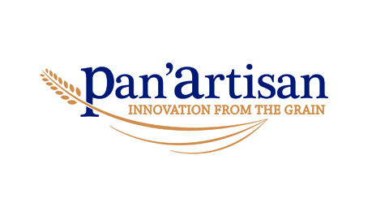

**JOB DESCRIPTION**

Position: **ASSISTANT LINE SUPERVISOR**

Report to: **LINE SUPERVISOR**

Hours of work: Shifts between 6am and 10pm from Monday to Friday

Shift between 6am and 12pm on Saturday if required.

Job purpose: Providing the required back-up and support to the line supervisor by operating the production line ensuring the smooth and efficient operation of equipment and staff to produce a consistent quality product, conforming to the required standards.

Responsibilities:

* Assist the line supervisor in setting up the line at the start of the shift.
* Support the line supervisor by checking and ensuring that the equipment being operated is in good working order before use, reporting any issues to the engineers.
* Effective operation of equipment to ensure the production line runs efficiently.
* Accurate and timely completion of all required documentation when requested to do so in an eligible manner.
* Adherence to recipes and ensure that the quality of the products meets the required company standards.
* Comply with company health and safety policies and report any issues, including near misses.
* Maintain a high level of housekeeping and hygiene at all times, while adopting “Clean as you go” approach, and cleaning of line at end of shift.
* To adhere to Good Manufacturing Practices at all times, which includes food safety, housekeeping and process adherence.
* Where applicable, ensure that CCP’s are correctly managed.
* To perform any other reasonable tasks requested by supervisors and managers.

Key qualities and skills:

* Attention to detail and pride.
* Ability to work under own initiative and meet the required standards.
* English is the language of operation on site
* Physically able to complete the required tasks effectively.